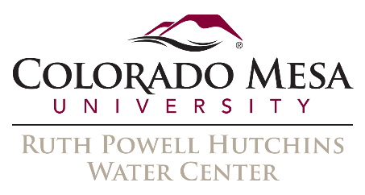 | 2016 Water Course:  Planning for Resilience

Speaker Biographies

February 25, Session 2

Mark Hermundstad
Attorney, Williams, Turner & Holmes, PC

Mark A. Hermundstad practices law in Grand Junction and is a shareholder in the law firm of Williams, Turner & Holmes, P.C. He graduated from the University of Wisconsin-Stevens Point and received his law degree from the University of Colorado. Mr. Hermundstad is licensed to practice law in Colorado and Utah. His practice concentrates on water rights and real estate matters in Western Colorado and Eastern Utah. Mr. Hermundstad’s water rights clients include ranchers, businesses and energy companies, local government entities, irrigation organizations, and individual landowners. He has given numerous presentations on water law, governmental law, and other legal topics to various community, business and professional organizations.

Gregory J. Hobbs, Jr.
Distinguished Jurist in Residence and Co-Director, Environment and Natural Resources Program,
University of Denver Sturm College

Gregory J. Hobbs, Jr. served as Justice of the Colorado Supreme Court from May 1, 1996 to August 31, 2015. Currently, he is Senior Water Judge assigned to mediation for the seven Colorado Water Courts and Co-Director of the Environment and Natural Resources Program of the University of Denver Sturm College of Law. He is also Co-Convener of Dividing the Waters, National Judicial College Educational Program for Water Judges and Hearing Officers. Mr. Hobbs has also authored five books of water history, culture, law, and poetry. He earned his J.D. at the University of California Berkeley in 1971, and a B.A. History University of Notre Dame in 1966. He was a Peace Corps Volunteer in Colombia from 1967-68; former Enforcement Attorney, U.S. Environmental Protection Agency; Assistant Attorney General State of Colorado Natural Resources Section; Partner in the Denver law firms of Davis, Graham & Stubbs and Hobbs, Trout & Raley (1973-1996); Associate Cooper, White & Cooper, San Francisco 1972-73, and Law Clerk to Judge William E. Doyle, 10th U.S. Circuit Court of Appeals from1971-72. Mr. Hobbs has been admitted to the Bars of Colorado and California (inactive).

