Colorado Mesa University

PARTICIPANT HANDBOOK
2014-2015

Manager of Intramural & Club Sports: Bill Moorman
E-mail: bmoorman@coloradomesa.edu
Office: 970.248.1591
Table of Contents

Intramural Calendar | Pg. 3
What are Intramural Sports? | Pg. 4
Safety Precautions and Insurance | Pg. 4
How to Enter | Pg. 4
Participation Eligibility | Pg. 6
Free Agents | Pg. 7
Player Conduct | Pg. 7
Captain’s Responsibilities | Pg. 8
Rescheduling | Pg. 9
Postponements | Pg.10
Forfeits | Pg. 10
Defaults | Pg. 11
Sportsmanship Ratings | Pg. 11
Playoffs | Pg. 12
Awards  *Changes from the 2013-2014 season are highlighted in grey. | Pg. 13

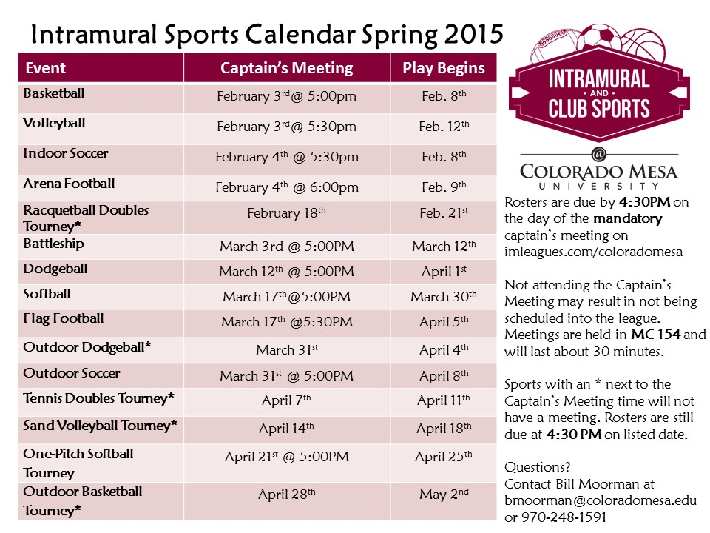

What Are Intramural Sports?

The Colorado Mesa University Intramural Program is dedicated to offering a recreational sports option for students, faculty, and staff FREE of charge. The Intramural Program offers a wide variety of recreational sports in team competitions as well as individual competitions. League play (basketball, volleyball, flag football, etc.) is usually six weeks including playoffs each semester. Tournaments (tennis, dodgeball, billiards, etc.) are usually one or two-day events.

Safety Precautions and Insurance

The CMU Intramural Sports program includes several sports that may be physically demanding and may be potentially hazardous for participant. It is strongly recommended that all participants undergo a routine physical exam by a physician before commencing participation in the program.

Colorado Mesa University does NOT provide Intramural participants insurance coverage and does not take responsibility for medical costs incurred as a direct or indirect result of students’ participation in Intramural Sports.

Each individual participating in Intramural Activities assumes the responsibility for his or her health and safety. Those who have had previous injuries that may recur, or who are not physically suited to a particular activity are urged to reconsider their participation in the Intramural Program for safety reasons.

Colorado Mesa University and its Intramural Sports Office assume no responsibility for injuries incurred during or as the result of participation in sponsored activities. Each participant will be required to review and sign a Participation Waiver of Liability, Assumption of Risk and Indemnification Agreement which must be signed when creating an account on imleagues.com

Intramural competitions are supervised by staff who have limited training in emergency procedures.

How to Enter

We have fully transitioned to the use of http://www.imleagues.com/coloradomesa for signing up and scheduling intramurals. A legal roster must have the minimum number of players to field a team for the sport in question. The minimum number of registered players will be listed on the sign up form online. The online roster must be complete by the designated deadline date. The online roster will be official and everyone must be listed to play.
Contact the Intramural office immediately if you have problems adding players. There will be no exceptions to not having a complete online roster.

The minimum number of players must be entered online by 4:30pm on the date of the registration deadline. All individuals attending the meeting MUST sign in when they arrive. If there are more entries than available spaces for a particular activity, a waiting list will be created. If a team forfeits out of a league, the team on the top of the waiting list will be given the first opportunity to fill the vacancy. If the first team on the waiting list is unable to fill the vacancy, the second team on the list will be contacted. This will continue until the vacancy has been filled or all teams have been contacted.

All Intramural participants will be REQUIRED to create an account on IMLeagues.com.
To create an IMLeagues account: **Note** IMLeagues offers a live support button in the bottom right corner of all pages; please use this button if you encounter any difficulties.
1. Go to http://www.imleagues.com/coloradomesa. And click Create Account
2. Enter your information, and use your Colorado Mesa University email (@mavs.coloradomesa.edu) and submit.
3. You will be sent an activation email, click the link in the email to login and activate your IMLeagues account.
4. You should be automatically joined to your school – If not you can search schools by clicking the “Schools” link.

How to sign up for an Intramural Sport:
1. Login to your IMLeagues.com account.
2. Click the Create/Join Team Button at the top right of your User Homepage
OR
Click on the “Colorado Mesa University” link to go to your school’s homepage on IMLeagues.
3. The current sports will be displayed, click on the sport you wish to join.
4. Choose the league you wish to play in (Men’s, Coed, Women)
5. You can join the sport one of three ways:
a. Create a team (For Team Captains)
i. Captains can invite members to their team by clicking the “Invite Members” link on the team page. Any invited members must accept the invitation to be joined to your team.
1. If they have already registered on IMLeagues: search for their name, and invite them.
2. If they have NOT registered on IMLeagues: scroll down to the “Invite by Email Address” box, and input their email address.
b. Join a team
i. Use the Create/Join Team Button at top right of every page
ii. Accepting a request from the captain to join his team
iii. Finding the team and captain name on division/league page and requesting to join
iv. Going to the captain’s player-card page, viewing his team, and requesting to join.
c. Join as a free agent
i. You can list yourself as a free agent in as many sports you’d like. You will be visible to all members of the site and can request to join teams, or post information about yourself so teams can request to add you to their team.

Participation Eligibility

Each team captain and participant is responsible for verifying the eligibility of their team. Questionable cases should be referred to the Manager of Intramural and Club Sports prior to participation. When a specific case is reported, an inquiry will be made to determine the eligibility of the player.

- The following individuals are eligible to participate in Intramural Activities:
  - All CMU student/staff/faculty with the ability to obtain an active MavCard.
  - You will be REQUIRED to present your MavCard before each game.

- The following individuals are NOT eligible to participate in Intramural Activities:
  - Alumni
  - Individuals who are unable to attain a Mavcard.

- Only two “highly competitive” athletes may play on any intramural sport team. A “highly competitive” athlete is one who competes at the varsity or club level for that sport.

- CMU Club Sports Members – Members of CMU Club Sports are allowed to participate in their respective Intramural Sport, however, a maximum of two (2) Club Sports members total (any combination of two club members from men’s or women’s) are allowed on any one Intramural Team. A person is considered a club member if (including, but not limited to): filled out club forms, practices, travels, and/or plays in club competitions.

- A player may NOT compete as a member of two teams in the same Intramural Activity. However, a participant may play on one men’s or women’s team and also compete on a co-rec in the same sport.

- Any team caught using an ineligible player(s) shall forfeit all games in which that player participated, and surrenders their right to compete in any playoff competition (Intramural Staff reserves the right to verify player eligibility at any time).

- To be eligible to participate, a player must be listed on the online roster on imleagues.com/coloradomesa by the deadline assigned for that sport. Participating in the regular season without being on the roster will not allow players to play in playoffs. Should there be any problems getting a player registered, contact the Manager of Intramural and Club Sports immediately at bmoorman@coloradomesa.edu. A player’s name must appear on the game scorecard and the player must have participated for at least one league game in order for him/her to be eligible for participation in the playoffs.

- ***YOU WILL BE REQUIRED TO PRESENT YOUR MAVCARD PRIOR TO EACH GAME***

- All players will submit their Mavcards to the score table at the start of their contest. The score table will keep the Mavcards until the conclusion of the contest.

- Women may play in a men’s league provided no comparable sport league was offered for women.

Free Agents

If you would like to participate in ANY Intramural Activity, but have not yet found a team or partner, you can become a FREE AGENT.

- All Intramural Registration is now completed online through IMLeagues.com/coloradomesa.

- See page 6 of this handbook for all information regarding online registration as a Free Agent.

Player Conduct

The philosophy of Intramural Sports is to provide exercise, diversion, and fun to participants in a relaxed, yet structured environment. Guidelines are set forth to protect the interests of all participants. All actions and comments, whether to officials, supervisors, participants, or spectators should be constructive, if offered at all. The following guidelines for participants and spectators should assist teams in reinforcing a positive atmosphere:

- Participants and spectators are expected to behave in a cooperative, positive manner, which contributes to the Intramural philosophy for the Spirit of Competition.

- All vulgar, obscene, abusive, derogatory, and demeaning comments or gestures create a hostile environment, generate ill will, and contribute to a negative Intramural experience. THIS BEHAVIOR WILL NOT BE TOLERATED and may result in disciplinary action.

- All instances of unnecessary roughness, attempting to injure another person, threatening another person, provoking an altercation, or fighting will result in severe disciplinary action.

- Participants and spectators are expected to comply with requests and directives of all Intramural personnel in a respective, pleasant manner.

- Teams may be penalized for the actions of their spectators as well as their team members.

- Individuals and teams that violate these guidelines will be disciplined at the discretion of the Manager of Intramural and Club Sports.

Ejections

a. Players removed from any Intramural contest, by an official or supervisor for any incident will be suspended from all Intramural activities and must seek reinstatement from the Manager of Intramural and Club Sports.
b. The supervisor will ask the ejected participant to leave no more than two times. If the participant does not comply, Campus Security will be called immediately. The case will then be reported to the Student Conduct Office.
Suspension of players can be in increments of a game, season, year, or a lifetime ban.

Alcohol and/or drugs

We understand that some of our participants are of legal age to consume alcohol and/or marijuana. However, participants may not be under the influence of drugs or alcohol at any time during an intramural contest. Those in violation of this rule may be ejected from competition and referred to the Student Conduct Office.

Captain’s Responsibilities

As a team captain, you serve as a vital link between the Intramural Sports staff and your team members. Some of the specific duties include:

- Filling out and submitting all necessary forms (team entry form, roster addition form, waivers, etc).

- Selecting the division, day, and time that your team will compete. Attend the mandatory captain’s meeting. If you cannot attend, you must find a substitute from your team. Failure to attend can result in that team is dropped from the league.
- Understanding the policies and procedures in this Intramural Participant Handbook, and making sure all team members understand and abide by them.

- Notify your team members of the date, time, and location of contests.

- Be familiar with sport specific rules.

- Ensuring that enough team members are present at each game to avoid a forfeit.

- Accepting responsibility for the actions of all team members and spectators.

- Maintaining a cooperative attitude with all Intramural Officials and supervisors.

- Any concerns in regards with officiating must be brought to the site supervisor by the captain only. If the issue is not resolved the captain may then request assistance from the Manager of Intramurals.

- Ensure your team members know they MUST submit THEIR MAVCARD before each game.

Rescheduling

Due to the number of teams, the short playing season, and limited playing facilities, rescheduling will be kept to an absolute minimum.

- Teams sign-up to play on a given day/time and they will be held accountable to play at those times.
- Arrangements for a rescheduled game must be made via email to the Manager of Intramural and Club Sports, and should be initiated at least 1 week prior to the originally scheduled contest.
- It is the captain’s responsibility to contact the Intramural Office to request the game change.
- Playoff games will NOT be rescheduled unless there has been approval from the Intramural Office.

Postponements

Facility conflicts and rain-outs are unfortunate realities of Intramural Sports. The Intramural staff will try their best to keep all participants well informed via email, calls and by updating the website/Facebook page.

Rain-Outs

Never, ever, assume that a game will be cancelled because of rain. The Intramural Sports staff will determine if games are postponed due to inclement weather.

The factors that will be considered are field conditions, weather conditions, and participant safety. NO scheduled games will be postponed due to inclement weather prior to 1.5 hours before the start of the scheduled contest.

**Every effort will be made to reschedule games that are postponed or rained out, but understand facility and staffing constraints may prevent a reschedule.**

Forfeits

Game time is forfeit time. If a team is not ready to play at game time, a forfeit may be assessed. If a captain contacts the Manager of Intramurals at least 24 hours in advance, a grace period may be requested. “Ready to play” means a team has the minimum amount of players to play signed in to the score sheet. In case of an unavoidable delay, starting time may be extended at the discretion of the Manager of Intramural and Club Sports or supervisor of that sport.

Forfeits may be assessed for the following:

- Use of ineligible players
- Failure to have a minimum number of players present to begin the contest.
- Not appearing at a scheduled contest.
- A team, individual participant, or spectator exhibiting unsportsmanlike or disruptive behavior may result in a forfeit. Team captains may be warned prior to the forfeit of the contest. The decision of the official and supervisor will be final.
- One forfeit makes a team ineligible for playoffs.
- Two forfeits in the same league will result in the team being dropped from the league.
- Forfeits will result in:
- The opponents shall win by a score of 1-0
- “0” sportsmanship rating for the team forfeiting & a “3” sportsmanship rating for the winning team.

Defaults

1. Defaults are a way of avoiding a forfeit. To avoid a forfeit in which you know your team will not be able to make the game, call the Intramural Sports Office at 970-248-1591 or e-mail bmoorman@coloradomesa.edu at least 24 hours before your game and notify the office that you cannot play and explain why. By doing so, your team may receive a default (i.e. a loss), which keeps you eligible for playoffs. Teams may only request a default loss twice during the season. Defaults in excess will result in a forfeit.

Sportsmanship Ratings

Playing with class, along with safety, are the most important elements in Intramural Sport participation. The sportsmanship rating system is used to assist officials and supervisors in evaluating the sportsmanship of participants and spectators. The system will allow officials to rate teams and spectators on communication respect for opponents, officials, and unsportsmanlike conduct.

Teams will be rated on a 4-point scale. Four being excellent sportsmanship, and zero being poor. Teams will be rated at the conclusion of each game by the officials and the on-field supervisor(s). Teams must have above a 3.0 sportsmanship average over the regular season in order to make playoffs. Any team that has a player ejected can receive no higher than a two rating for that game.

A (4.0) – Excellent Conduct and Sportsmanship: Players cooperate with the Intramural Staff and other team members. The captain calmly converses with the Intramural Staff about interpretations and calls. The captain also has full control of his/her teammates and spectators.

B (3.0) – Good Conduct and Sportsmanship: Team members complain about some decisions made by Intramural Staff and/or show minor dissension which may or may not receive an unsportsmanlike penalty. Teams receiving one unsportsmanlike penalty will receive no higher than a “B” Rating

C (2.0) – Average Conduct and Sportsmanship: Teams show verbal dissent towards Intramural Staff and/or the opposing team, which may or may not merit an unsportsmanlike penalty. Captains exhibit minor control over his/her teammates. Teams that receive two unsportsmanlike penalties will receive no higher than a “C” Rating.

D (1.0) – Below Average Conduct and Sportsmanship: Teams constantly commenting to the Intramural Staff and/or opposing team from the field and/or sidelines. The team captain exhibits little or no control over teammates or himself/herself. Teams receiving more than two unsportsmanlike penalties or having a player ejected due to sportsmanship will receive no higher than a “D” Rating.

F (0.0) – Poor Conduct and Sportsmanship: Team is completely uncooperative. Captain has no control over teammates, and/or himself/herself. Any team causing a game to be forfeited by result of unsportsmanlike behavior, and/or having multiple unsportsmanlike penalties and/or more than one player ejections will receive an “F” Rating.
NOTE: Any team that receives a “D” Rating or below will automatically be suspended for their next scheduled game and the team captain must meet with the Manager of Intramural Sports prior to participating in any additional Intramural contest.

NOTE: If any player is ejected, the player will need to meet with the Manager of Intramural Sports prior to being reinstated. The Manager will determine if the player will also meet with the head of the Disciplinary Action board at Colorado Mesa University

Sportsmanship Rating during Playoffs

In order for teams to continue to play in the playoffs they must receive “A” or “B” sportsmanship rating in every game.

Playoffs

All teams will qualify for the playoffs provided that they have a have an overall sportsmanship of 3 or better and did not forfeit a regular season contest.

Brackets and seeding will be arranged by the Intramural Sports staff and the following criteria will be used:

- Overall Record
- Sportsmanship Rating
- Head-to-Head Record
- Coin Flip

*Weekend (or 1 day tournaments) will be randomly seeded.

Team captains will be notified of their team’s first playoff contest via e-mail, and it is his/her responsibility to notify the rest of their team.

NOTE: Playoff games will NOT always be during your team’s preference to play. However, to accomplish the tournament by the end of the semester, we cannot reschedule playoff games. We are sorry for this inconvenience.

Awards

Intramural Sports Champion T-shirts will be awarded to the champions of the Intramural Leagues and Tournaments. Intramural Champions will have their team/individual photo uploaded to the Facebook page and to the Intramural Sports website.

A participant will ONLY receive a championship shirt if they are on the roster for that team and they have played in at least one regular season game. In the event a player is unable to make the championship game and his/her’s team wins, the player can contact the Manager of Intramurals and request a shirt.

