Open Education Resources (OER) Supplementary materials for PHYS 131: Fundamental Mechanics

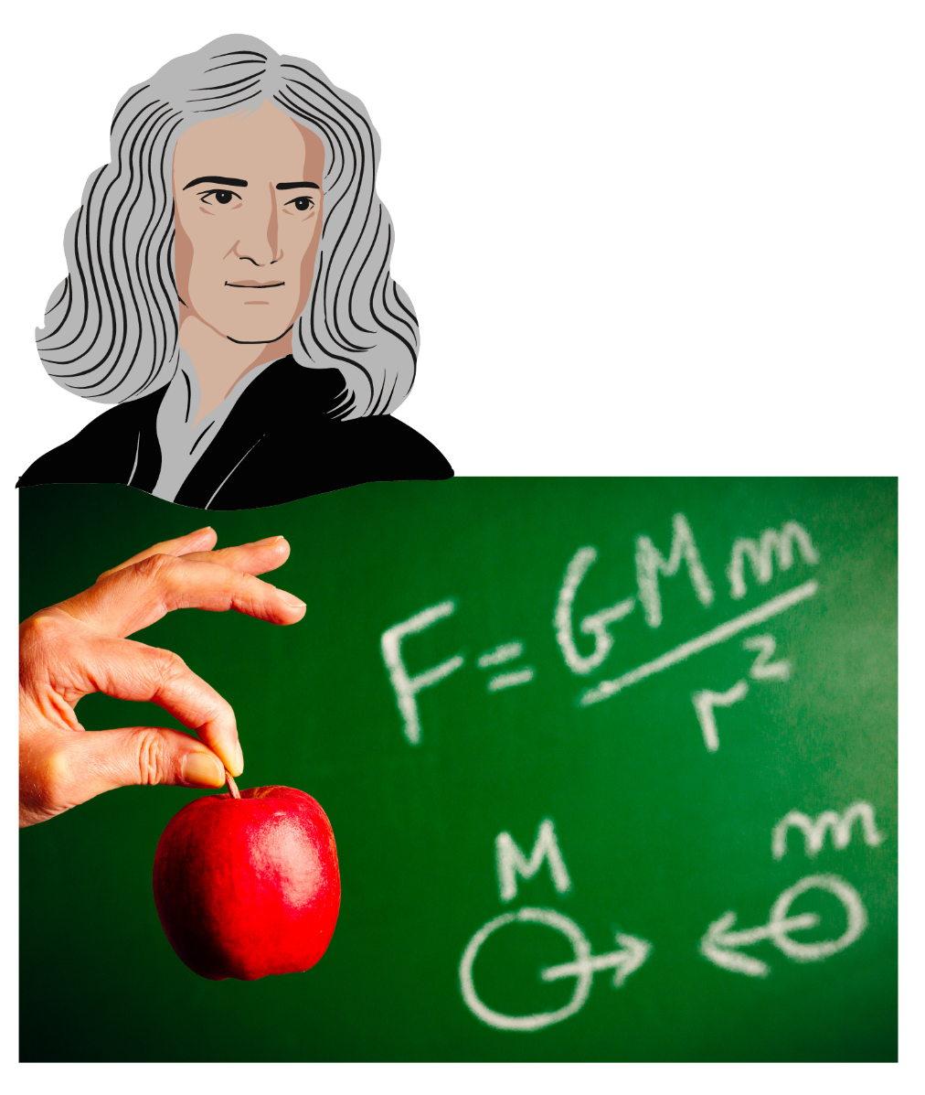

Dr. Youngmin Kim

Department of Physical Environmental Sciences, Physics
Colorado Mesa University

Content

0: Get to know your classmates
[An example how to break ice in the first week]

1: Drag Race between Electrical Vehicle (EV), and Internal Combustion Engine Vehicle (ICEV)
[Concept of instantaneous, average velocity and acceleration]

2: Galileo’s Free-fall Experiment
[Utilizing Galileo’s thought experiment on an incline for a constant gravitational acceleration]

3: Trigonometry/Component vectors exercise
[Trigonometry properties review, decomposition of vectors in a 2D cartesian coordinates]

4: Projectile motion of a football
[2 dimensional kinematics, projectile motion]

5: Introduction to Forces
[Newton’s 1st and 2nd Law concepts]

6: Inertial frame of reference, mass, weight
[Mass, weight, gravity]

7: Drag force and Terminal velocity in Skydiving
[Calculating the terminal velocity of a skydiver with different drag coefficient]

8: F-150 crankshaft’s rpm, rotation of Earth
[Uniform circular motion, centripetal acceleration]

9: The Latitudes of the Earth
[Calculating angular, tangential velocity in different locations around the world]

10: Centrifugal phenomenon; artificial gravity
[Concept of centrifugal effect, centrifuge]

11: Power and Energy saving
[Power consumption, lightbulbs, energy saving]

12: The potential Energy in the Hoover Dam
[Gravitational potential energy]

13: Using the Impulse to estimate an automobile collision injury
[Momentum, Impulse, average Force in an automobile accident]

14: Calculating the recoil velocity of a rifle.
[Conservation of momentum, explosion, muzzle velocity, recoil velocity and force]

Small Group Discussion #0 – Kick off week

Name: Other members:

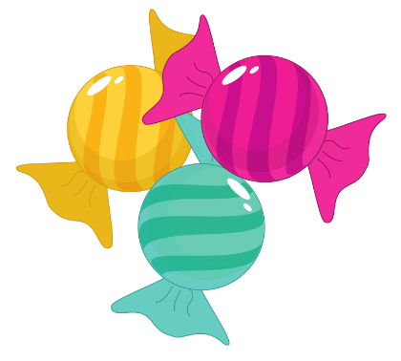
Get to know your classmates!

Instructions:
Step 1: Take one Tootsie Roll.
Step 2: Find your group with the same Tootsie Roll color.
Step 3: Get to know your group member by asking the following questions:
Step 4: Write down responses for at least one person in your group.
- What is your name and your major?

- Why have you chosen your major?

- How was your previous experience with physics (if any)?

- Are you looking for a study group?

Small Group Discussion #1

Name: Other members:

Drag Race between Electrical Vehicle (EV)
and Internal Combustion Engine Vehicle (ICEV)
Instructions:
Step 1: Form a small group of 4 people. Write down their names.
Step 2: Understand the comparison chart between Tesla Roadster vs. Bugatti. Make sure everyone is on the same page.

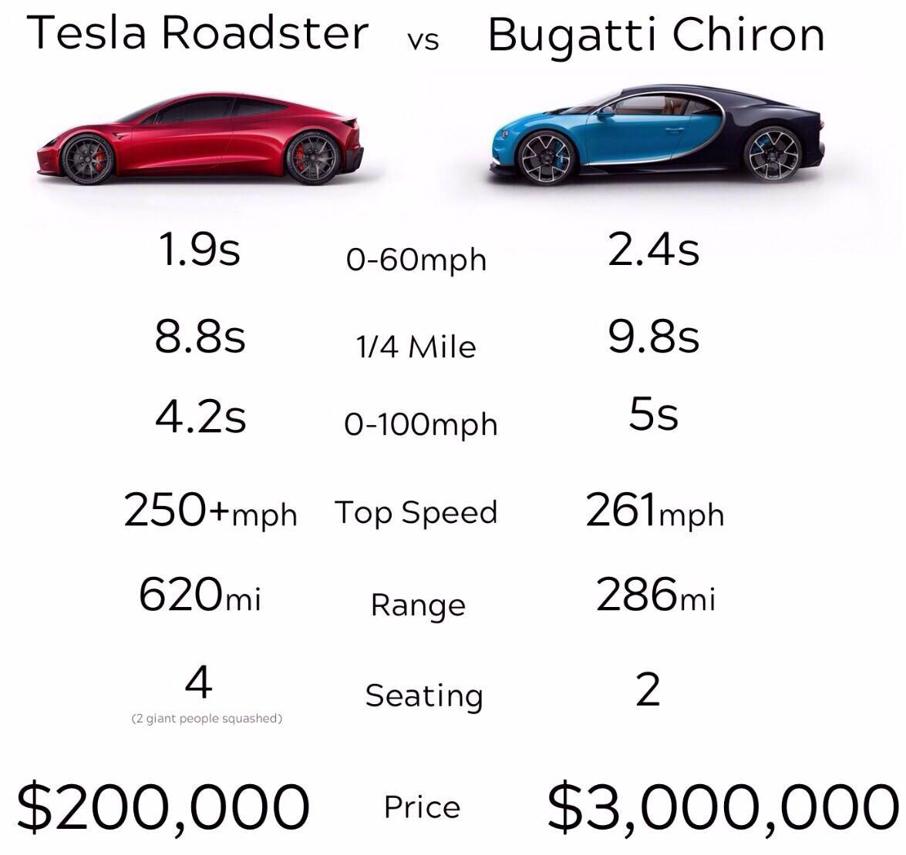

Step 3: Answer the following questions regarding the Tesla Roadster as a group.
- Find an average velocity for the Tesla Roadster.

- Find two instantaneous velocities at two different times, t.

- Find an average acceleration.

Small Group Discussion #2

Name: Other members:

Galileo’s Free-fall experiment

Instructions:
Step 1: Form a small group of 4 people. Write down their names.
Step 2: Understand the inclined diagram. Make sure others are on the same page.

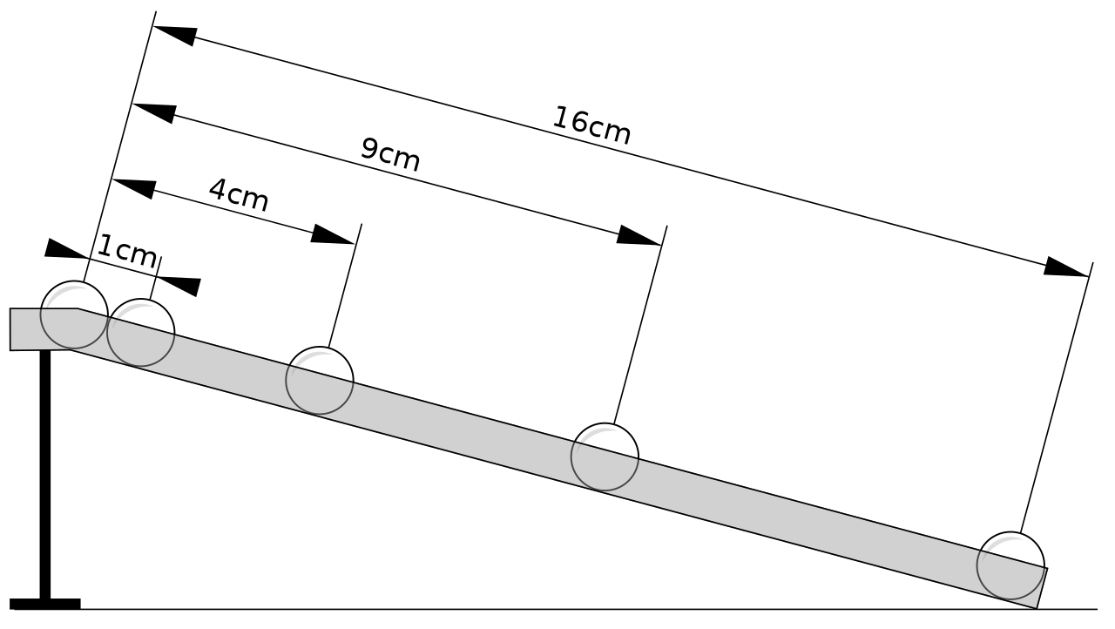

Step 3: Answer the following questions as a group.
- How is this experiment equivalent with the Tower of Pisa’s? (Ignore friction)

- How is the acceleration related to the inclined angle $θ?$

- Use kinematics equations to calculate the distances and velocities an object travel with for t = 1 – 4s.

Small Group Discussion #3

Name: Other members:

Trigonometry/Component Vectors Exercise
Instructions:
Step 1: Form a small group of 4 people. Write down their names.
Step 2: Answer the following questions as a group.
- Draw a right-angle triangle with an angle, $θ,$a, b and c as the diagonal.

- Write out the definition of the following properties using $θ,$a, b and c:
$$\sin{θ=} \\ \cos{θ=} \\ \tan{θ=} \\ \left|c\right|=$$

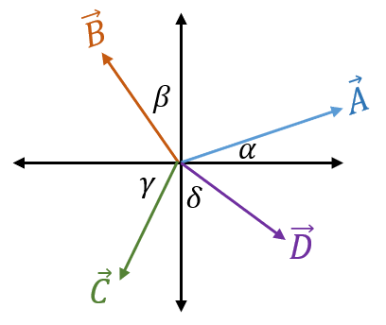
- Find the vector components for $\vec{A},\vec{B},\vec{C} and \vec{D}$.
$$A_{x}= \\ A_{y}= \\ B_{x}= \\ B_{y}= \\ C_{x}= \\ C_{y}= \\ D_{x}= \\ D_{y}=$$
Small Group Discussion #4

Name: Other members:

Projectile motion of a football
Instructions:
Step 1: Form a small group of 4 people. Write down their names.

Many NFL Quarterbacks can throw a football for a distance of 60 yards. Not may can throw beyond 60 yards but Jay Cutler was among the few who could. According to the NFL’s Next Gen Stats, Cutler threw a football the farthest in the air of nay quarterback in the NFL in 2016. Officially it was a 50-yard touchdown, but Cutler was standing near the numbers on the right side of the field, and threw it about eight yards deep in the end zone on the left side of the field, for a total distance of 65 yards.

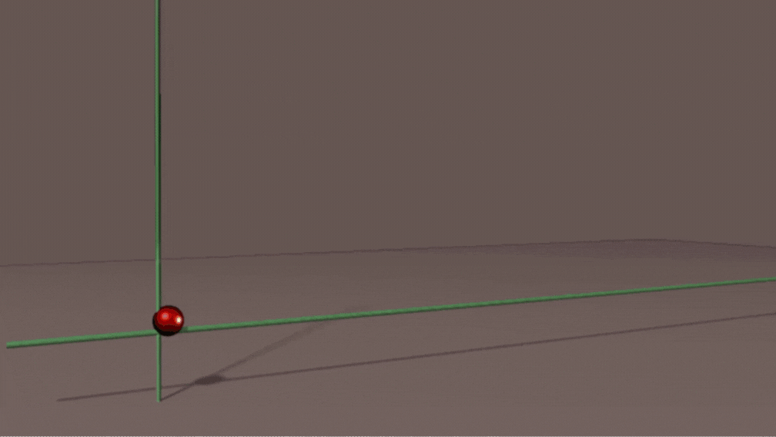

Step 2: Answer the following questions as a group. (1 yard = 0.9144 m, 1 mile = 1,609 m)
- Under air resistance, 50 degree is the angle of the maximum distance. What is Cutler’s initial throwing speed in m/s if he throws 65 yards? Convert it into mph.

- Suppose the football is thrown into the stands where a spectator is sitting 5.0 m above the point where the football is thrown. a) Calculate the time it takes the boot to reach the spectator. b) What is the impact speed of the ball at the spectator?

Small Group Discussion #5

Name: Other members:

Introduction to Forces
Instructions:
Step 1: Form a small group of 4 people. Write down their names.
Step 2: Discuss the following scenario with your group.

An astronaut floating weightlessly in orbit shakes a large iron anvil rapidly back and forth. First, describe where in this motion, the astronaut is exerting a force. How does her effort of shaking the anvil compare with if she were on Earth?
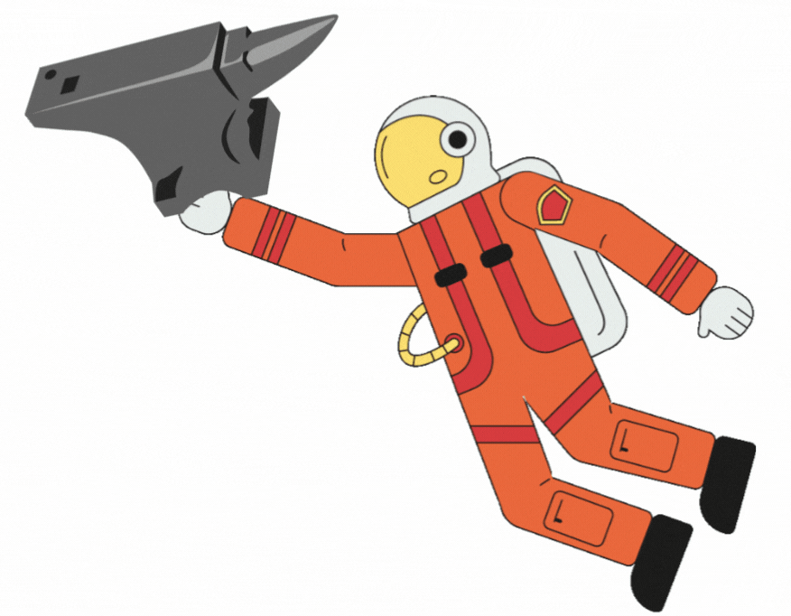

Step 3: Find answers to the following True and False questions:
An apple can move even when no force acts on it. (T or F)

If an apple isn’t moving, no external forces act on it. (T or F)

Can a single force acts on any object? (T of F),

If there is only one single net force acting on the apple, it accelerates. (T or F)

If an apple isn’t accelerating, no external force is acting on it. (T or F)

Small Group Discussion #6

Name: Other members:

Inertial frame of reference, mass, weight

Is the Earth an inertial frame of reference why or why not?

Where will you receive your gold nugget? A newton of gold nugget on Earth or on the Moon, and why?

What is the weight of an astronaut in outer space, and why?

Small Group Discussion #7

Name: Other members:

Drag force and terminal velocity in Skydiving

The force of drag is given as: $F_{D}=\frac{1}{2}CρAv^{2};$ where C = drag coefficient, $ρ$ = fluid density,
A = area, v = speed. The terminal velocity is then derived from Newton’s 2nd Law as:

$$v_{T}=\sqrt{\frac{2mg}{ρCA}};m=mass, g=9.80\frac{m}{s^{2}}, ρ=1.21 kg/m^{3}$$

Assume a 6-foot-tall, a-90 kg-mass person with gears free-falling in two positions: 1) feet first, fastest, C=0.70, 2) perpendicular, slowest, C=1.0.
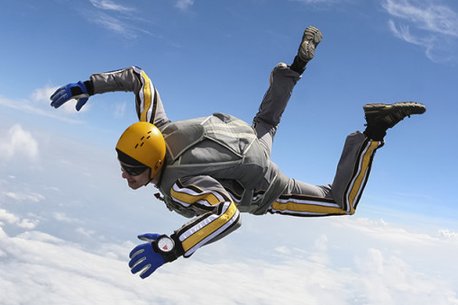

Calculate the terminal velocity for each two cases approximating the area.

Small Group Discussion #8

Name: Other members:

F-150 crankshaft’s rpm, rotation of Earth
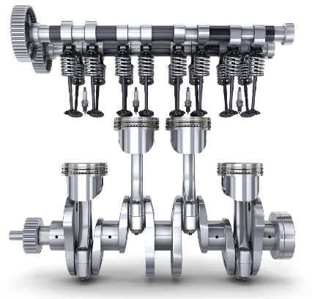
Given that an automobile’s crankshaft (F-150) has a diameter of 5.0 cm, calculate the angular and linear speed of F-150’s crankshaft rotating at 5000 rpm: $v=\frac{2πr}{T}=ωr$

Calculate the linear velocity (m/s) of a person at the Equator. ($R_{E}=6400 km)$

What is the magnitude of the centripetal acceleration due to Earth’s rotation in $\frac{m}{s^{2}}$ ?
$$a_{c}=\frac{v^{2}}{R_{E}};R_{E}=6400 km$$

Small Group Discussion #9

Name: Other members:

The Latitudes of the Earth
The latitude and the longitudinal angles are defined on a sphere (Earth) as in the figure below:
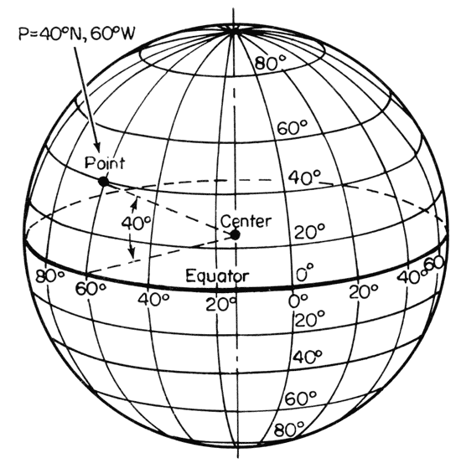
The Latitudes in three different locations are, London (52 N), Orlando (28 N) and the Equator. Calculate the angular, and tangential/linear velocity of a person standing in the three locations.

- Which location rotates with the fastest angular speed?

- Which location rotates with the fastest tangential/linear speed?

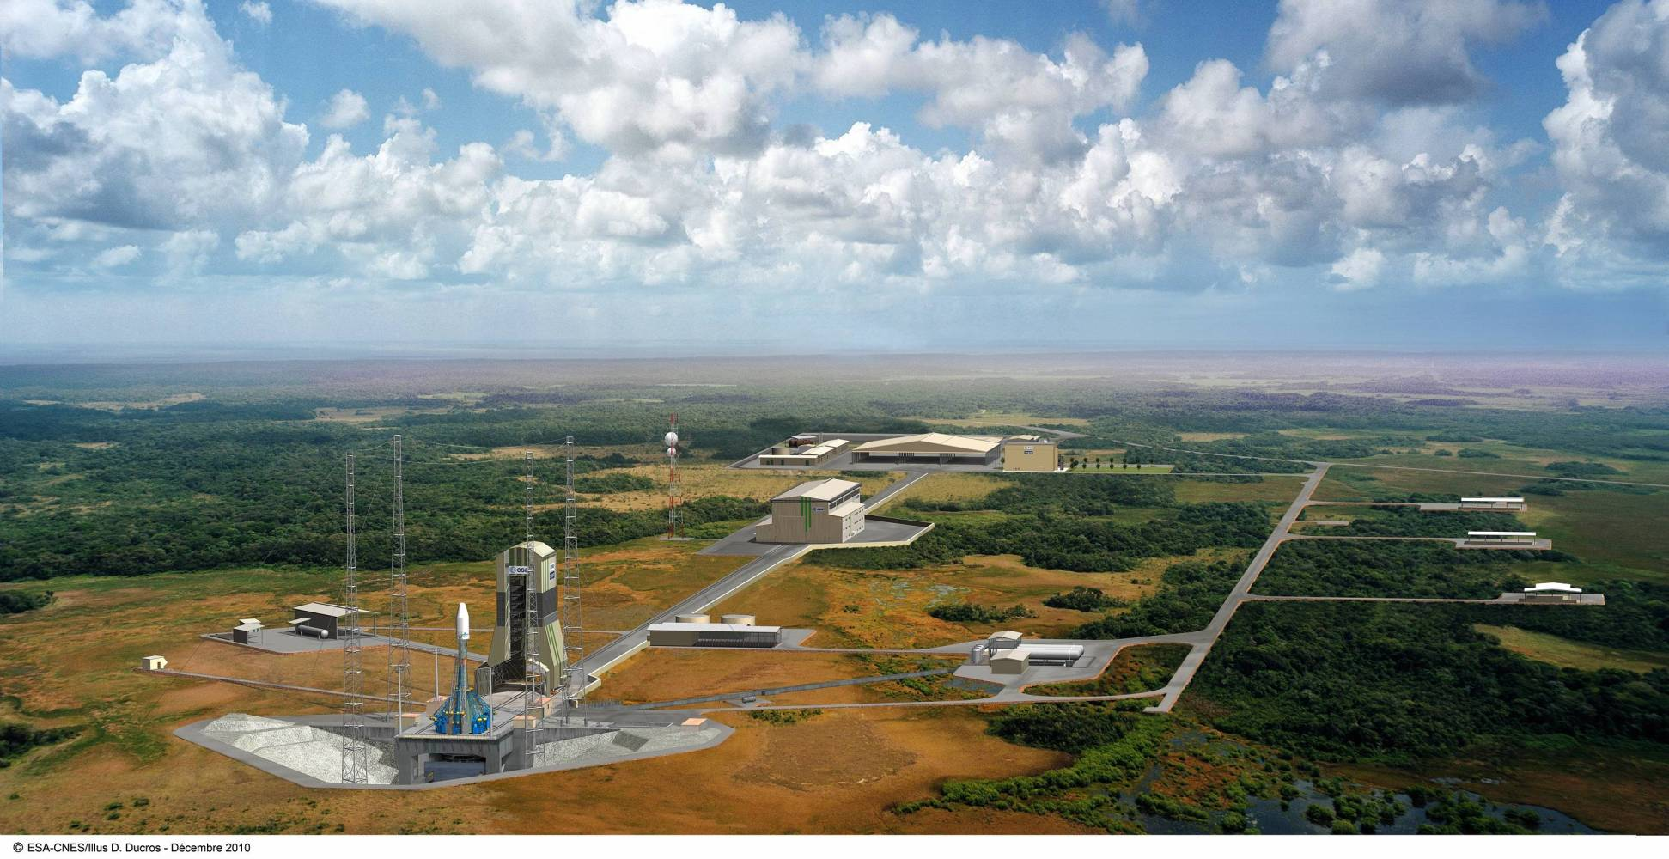
Based on the information above, discuss why the European Space Center for launching rocket is located not in Europe but in the French Guiana, South America. (Credit: Asmag.com)

Small Group Discussion #10

Name: Other members:

Centrifugal phenomenon; artificial gravity
Pilots and Astronauts go through rigorous training to overcome steep gravity changes in maneuver, so called g-lock induced unconsciousness. The centrifuge used on these trainings and in pharmaceutical industry or chemistry lab uses the same principle of centrifugal phenomenon, which is a fictitious force, an observer experiences in a non-inertial frame of reference.
The same principle can be applied to create an artificial gravity for a long journey in space, using the centripetal acceleration formula: $a_{c}=\frac{v^{2}}{r}.$

If a planned rotating space station has a radius of 100 m to the rim, calculate how fast must this space station rotate to create an artificial gravity of 1G = 9.80 $\frac{m}{s^{2}}$ at the outer rim.

Small Group Discussion #11

Name: Other members:

Power and Energy saving
Common household appliances come with a power rating or power usage in watts. For an example, store-bought residential LED light bulbs use 8.8 watts as shown in the image below:

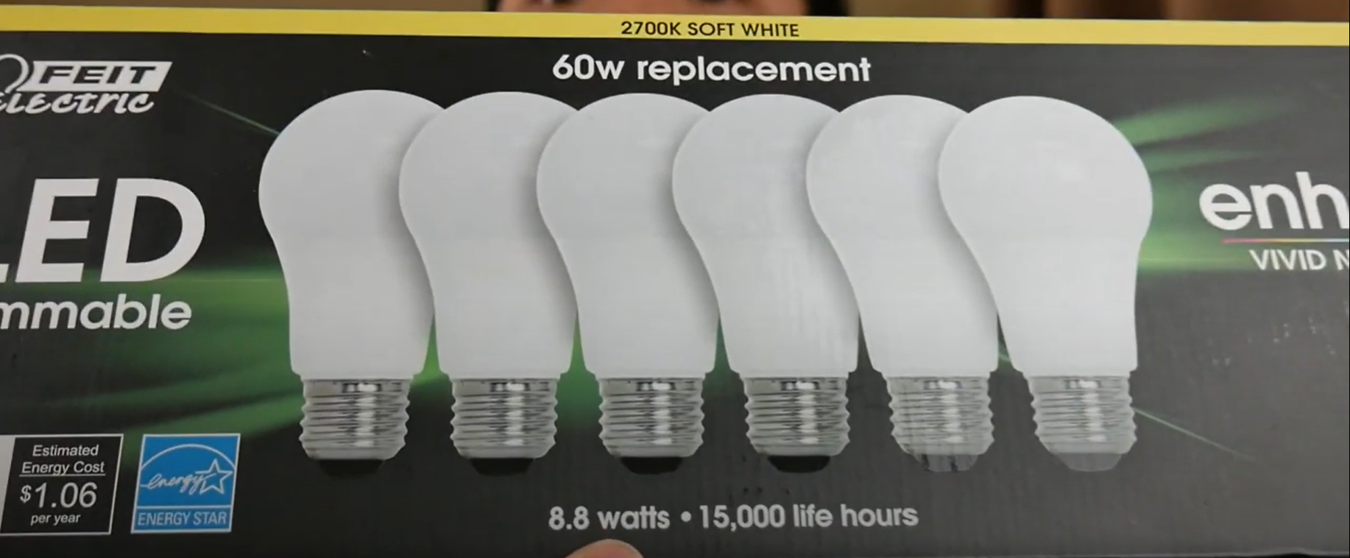

What does 8.8 watts mean in this context, and what does 60w replacement mean?

Using the definition of kilowatt-hour, 1 kWh = 1000 W x 3600 s = $3.60×{10}^{6} J$, first calculate the total yearly energy consumption of a household using 10 incandescent lightbulbs (100 W) used 6 hours per day in average, and a household using 10 LED lightbulbs (8.8 W) for the same amount of usage.

The cost of electricity in the state of Colorado in 2022 is 14c/kWh which can be found in your electricity bill every month. Use this price to calculate how much would a household save by switching all ten lightbulbs to LEDs.

Small Group Discussion #12

Name: Other members:

The potential energy in the Hoover Dam

“The water on the lake Mead holds a total of 10 trillion gallons of water, enough to cover the state of Connecticut 10 feet deep.” The height of the Hoover dam is 220 m to the base.
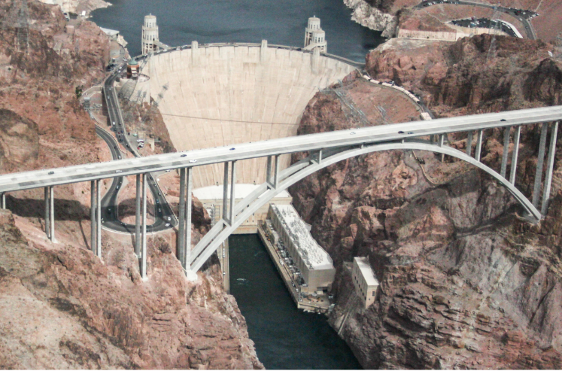
- Calculate the total mass of lake Mead’s water reservoir in kg. (1 gallon = 3.78 L)

- Using the gravitational potential energy = mgh, calculate the total change of potential energy if the entire lake Mead is to fall to the base. Use the midway of the dam’s height as an average.

- Einstein’s famous equation $E=mc^{2}$ (c = $3×{10}^{8} m/s)$ states that matter has energy even at rest proportional to its mass. What is the rest energy of a substance of 1 kg? Compare this with your answer above.

Note: The Hiroshima-size fission bomb has an energy of $4×{10}^{13} J$, a large fusion (hydrogen) bomb has an energy of $4×{10}^{16} J.$



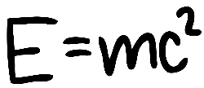

Small Group Discussion #13

Name: Other members:

Using the Impulse to estimate an automobile collision injury

What is the physical benefits of wearing a seat-belt in an automobile collision? In this exercise, you will estimate the fatality of a passenger in a car accident using the concept of impulse and the average force.

One estimate suggests a 90,000 N or more force could fracture a bone in an accident. Since the most vulnerable part of the body in a car accident is often the neck, a fracture in this context could lead to high fatality rate. The other crucial factor to consider is the head acceleration. If the head is subject to an acceleration greater than 150G, 50% or above fatality rate can be expected.

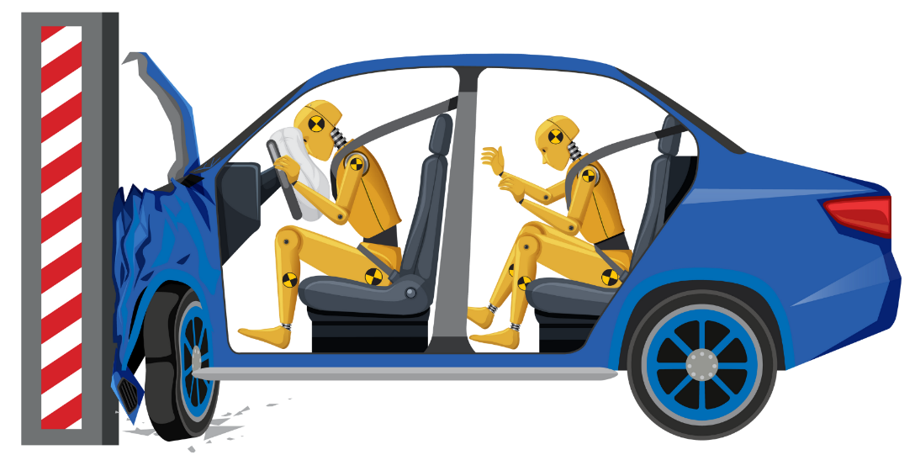
Suppose a student driver crashes into a standing tree. Let’s assume that the impact speed is 55 mph coming to an abrupt stop. There are two cases in comparison, one with a seat-belt, and the other without it. A typical stopping time, t for no seat-belt is 5 ms, while with the seat-belt, the time is increased to 25 ms.

- Using the definition of an average force: $\overline{F}=\frac{Impulse}{stopping time}=\frac{Δp}{Δt},$ calculate the average force in newtons exerted on the driver during the crash with a seat-belt, and without a seat-belt.

- Using the same stopping time data, calculate the average acceleration the driver experiences during the crash with a seat-belt, and without a seat-belt.

- Discuss in your group, using the above data in the introduction, the impact of wearing a seat-belt in this car accident. Estimate whether a bone fracture, and/or fatality can be expected.

Small Group Discussion #14

Name: Other members:

Calculating the recoil velocity of a rifle

The .220 Swift cartridge remains the fastest commercially available bullet in the world with a published velocity of 1,422 m/s. Suppose a hunting rifle weighing 8 lbs with a barrel’s length of 22 inches, is used to fire a 42 grams .220 Swift. The shooter holding the rifle weighs 170 lbs.
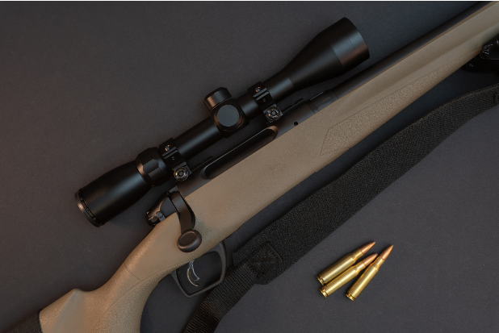
Using the conservation of momentum in an explosion,
- Calculate the recoil velocity upon firing. Use the muzzle velocity for the bullet.

- Calculate the average acceleration of the bullet as it leaves the barrel using the kinematics equations.

- What is the average force exerted on the shooter upon firing?

