Curriculum Vitae

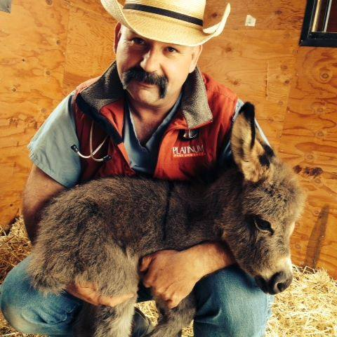

Personal Information
- Full Name: Braden Michael Louis Shafer
- Address: 1411 M Road Loma, CO 81524
- Phone Number: 970-858-7000
- Email Address: bshafer@coloradomesa.edu
- LinkedIn: linkedin.com/in/braden-shafer-75
- Website/Portfolio: www.shaferlargeanimalvets.com

Professional Summary
Compassionate and capable equine veterinarian with 30 years of industry experience. Good understanding of professional ethics and economics of the horse industry. Core values focus on client and student education and training, attracting today’s youth to careers in veterinary medicine, and philanthropic donation of time and financial resources to benefit the community.

Education
List your educational background in reverse chronological order, starting with the most recent degree. Include the institution, degree, field of study, and dates attended.
- Doctor of Veterinary Medicine
- Colorado State University, Fort Collins, CO
- 1996-2000

- Bachelor of Science in Zoology
- Colorado State University, Fort Collins, CO
- 1988–1992

- Colorado Mesa University, Grand Junction, CO
- 1987-1988 and 1993-1994
- Pursuit of pre-veterinary undergraduate requirements

- Ongoing veterinary continuing education

Professional Experience
- Director, Veterinary Technology Program
- Colorado Mesa University Tech
- 2025-Present

- CEO/Owner/Lead Veterinarian
- Shafer Large Animal Veterinary Associates, Loma, CO
- 2010– Present
- Lead a team of 3 veterinarians and 5 veterinary technicians in providing emergency and routine health care to horses and farm animals.
- Managed $800K in gross annual revenue to provide economic soundness, providing salaries and benefits to our beloved veterinary health care team.
- Developed a reputation for high-level sports medicine and lameness care, reproduction, and emergency support with staff training and aggressive equipment and technology acquisition.

- Equine and Bovine Associate Veterinarian
- Arrowhead Veterinary Services, Fruita, CO, 2005 – 2010
- Designed and outfitted an equine hospital for emergency and elective equine surgery, ICU care, and routine equine health care.
- Provided mobile equine and bovine emergency service across western Colorado.
- Provided mentorship and training to veterinary staff and students.
- Developed and maintained a robust clientele of equine owners and patients.

- Equine Associate Veterinarian
- Harris Equine Hospital, Grand Junction, CO
- 2001-2005
- Lead a team of veterinarians and veterinary technicians in providing emergency and routine health care to horses.
- Participated in business operations and team building as well as mentoring students.
- Independently managed complicated ICU cases, including post-operative colic, orthopedic, and medical issues.
- Provided mobile care for horses, donkeys, and mules in western Colorado.
- Provided client education with meeting lectures on emergency and orthopedic care of horses.

- Equine and Bovine Intern Veterinarian
- Elgin Veterinary Hospital, Elgin, TX
- 2000-3001
- Responsible for a wide variety of equine and bovine emergency and routine care.

Research Experience
- Research Assistant
- Colorado State University College of Veterinary Medicine Orthopedic Research Lab, Fort Collins, CO
- Dr. Simon Turner, Director
- Assisted in anesthesia, surgery, and general husbandry of research sheep as directed by the Animal Care and Use Committee (ACUC).
- Assisted in bone density studies and treatment of osteoporosis with the novel pharmaceutical raloxifene. Treated sheep for bone loss with a select frequency device for bone density. (Research papers available upon request).
- Assisted with anesthesia, surgery, pain management, and husbandry (per ACUC guidelines) for testing of orthopedic shoulder implants (cooperative with Steadman Clinic in Vail, CO).
- 1997-1998

- Research Assistant
- Colorado State University College of Veterinary Medicine Orthopedic Research Lab, Fort Collins, CO
- Dr. Wayne McIlwraith, Director
- 1991-1992
- Assisted with training horses for treadmill training and exercise post-surgical carpal surgery, which led to the development of the CSU equine carpal OA model used in research to this day.
- Assisted with harvest and histopathologic processing of equine carpal joints.
- Cared for research horses per ACUC guidelines.

Publications
- Shafer, B. (2020). "Passive Solar Device for Solar Heating of Stock Watering Devices.” USPTO 10,674,705 B2.
- Insight Magazine, CSUCVMBS

Presentations & Conferences
- "Back-country First Aid" – Invited Speaker, Colorado Mesa University Tech, Community Education, Grand Junction, CO
- "Equine Lameness" – Invited Speaker, Colorado Mesa University Tech, Community Education, Grand Junction, CO
- Attended dozens of continuing education meetings over the years. Topics include sports medicine and lameness, business management, dentistry, ophthalmology, surgery, and internal medicine.

Professional Affiliations
- President, Student Chapter American Association of Equine Practitioners, 1998
- Member, American Association of Equine Practitioners, 29 years.
- Member, American Veterinary Medical Association, 29 years.

Skills
- Diagnostic and treatment methods for a variety of equine health issues
- Strategies for equine preventive care and disease control
- Student mentoring and teaching
- Media liaison for veterinary issues (newspaper and television)
- Public speaking and classroom delivery
- Leadership and staff management
- Fiscal responsibility and business management
- Mental health and wellness mentoring

Honors & Awards
Showcase scholarships, certifications, and recognition received throughout your career.
- Ken Lawton Scholarship, 1999
- Pfizer Large Animal Proficiency Award, 2000
- Small Animal Anesthesia Award, 2000
- Dean’s List, 1999

Volunteer Experience
Highlight activities demonstrating social responsibility, leadership, and community involvement.
- 4H Veterinarian, County Fair, Grand Junction, CO
- CPRA Rodeo Veterinarian
- CMU Tech CVT training and mentorship
- Harmony Acres Therapy Center Veterinarian
- Dream Catcher Horse Veterinarian
- CMU Tech Lecturer for Community Education
- Board of Directors, Scholarship Committee Chair, Colorado Plateau Horseman’s Hall of Fame

References
- References available upon request.

