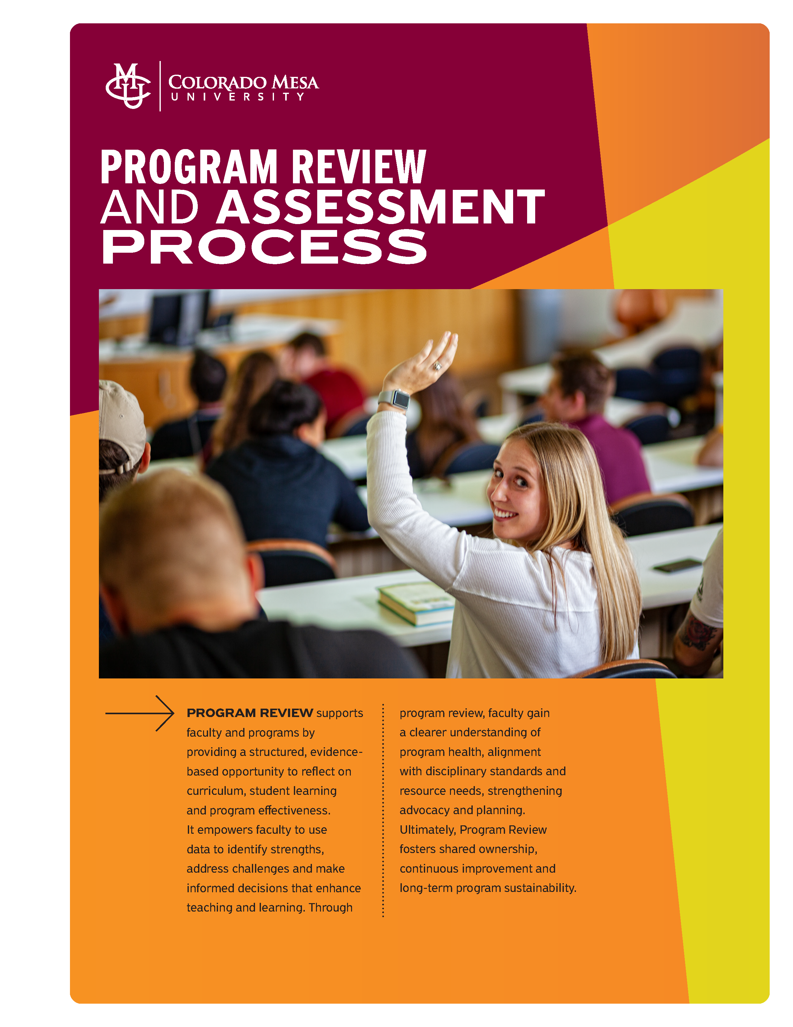

University Program Review and Assessment Process
Dear Colleague,
Program review serves to evaluate academic programs for effectiveness, efficiency, and alignment with the institutional mission. Program review isn't administrative oversight—it's your opportunity to tell your program's story, advocate for your program, and shape your discipline's future at Colorado Mesa University (CMU). Our seven core values—love, dignity, courage, resiliency, curiosity, humility and power— guide the review process. For CMU, aligning program review with our Human Scale University values means:
- Love & Dignity: Centering student well-being and treating all stakeholders respectfully
- Curiosity: Asking meaningful questions about program effectiveness rather than just compliance
- Humility: Honestly assessing strengths and weaknesses without defensiveness
- Courage: Making difficult decisions to improve or transform programs
- Resiliency: Building programs that adapt to student and community needs
- Power for Good: Using review outcomes to better serve your community
Program review becomes meaningful when it helps you be the educator you came here to be—not just checking boxes but genuinely improving how you serve students and advance your field. As educators, we should be asking the real questions of student success:
- Are we graduating students who think critically and care deeply?
- Are we preparing leaders who will improve their communities?
- Are we modeling the intellectual humility and collaborative spirit we want to see in the world?
Program review and assessment provide the why for higher education. Perspective students increasingly ask: "What will I actually be able to do after graduation?" Employers want to know that your graduates can perform, not just that they attended classes. Clear outcomes help you focus teaching efforts on what matters most. At CMU, a small university equals more visibility when students struggle, human scale means you actually know your students. Assessment should capture those relationships and transformations you're already seeing, aligning with regional employers and community partners as they expect CMU graduates to be work-ready. Assessment isn't busy work; it's documentation that your expertise and dedication actually matter.
Think about your academic program as you would for planning and leading a backcountry expedition in Colorado's wilderness.
Before the Trip (Program Design):
- You set a destination (learning outcomes) based on your group's abilities and goals
- You plan routes, check weather, gather proper gear (curriculum design)
- You know the terrain and potential hazards (student needs, industry demands)
During the Journey (Teaching & Learning):
- You constantly check your compass and map (ongoing assessment)
- You adjust routes when you hit unexpected obstacles (pedagogical flexibility)
- You ensure everyone stays together and reaches checkpoints (student progress monitoring)
Regular Check-ins (Assessment):
- "Where are we? Are we on track? Do we have enough water/food/energy?"
- You notice who's struggling and provide support before it becomes critical
- You celebrate when the group masters a challenging section
Program Review = Post-Trip Debrief:
- What worked well? What didn't work well?
- Did everyone develop the skills they needed?
- How can we improve the experience for the next group?
- Do we need different gear, training, or route planning?
Why It Matters: Just like you wouldn’t lead a group into the backcountry without navigation tools and safety checks, you wouldn’t guide students through their academic journey without assessment. At CMU, nestled in Colorado's outdoor recreation paradise, you're preparing students to be confident, capable guides in their own professional wilderness.

Table of Contents
Program Review Overview 4
Purpose 5
Review Cycle 5
Timeline 6
Program Review Committee Structure 6
Internal Review Committee 7
External Review Panel 7
Roles and Responsibilities 7
Assessment Framework and Data Collection 8
Program Review Process Phases 12
(Non-Accredited Programs) 13
Assessment Data Management 15
Continuous Improvement Framework 17
Stakeholder Communication 19
Appendices 20
Appendix A 21
Appendix B 21
Appendix C 26
Appendix D 34
Appendix E 37
Appendix F 38
Appendix G 40
Appendix H 41
Appendix I 43
Appendix J 45
Appendix K 46
*Revised 7.2026

Program Review Overview

Purpose
The program review process is designed to:
- Evaluate program effectiveness and student learning outcomes
- Identify strengths and areas for improvement
- Ensure alignment with institutional mission and strategic goals
- Support continuous improvement and quality assurance
- Inform resource allocation and strategic planning decisions

Review Cycle
- Comprehensive Review: Every 6 years (see Review Cycle- Appendix A)
  - Accredited programs will provide accreditation self-study for comprehensive 6-year review
  - Non-accredited programs will follow the program review self-study elements (see Program Review Self Study Elements- Appendix B)
- 3-Year Mid-Cycle Assessment: Ongoing data collection and continuous quality improvement (CQI) (abbreviated process to 6-year comprehensive)
  - 3-year assessment is for both accredited and non-accredited programs (see 3-year Assessment Template- Appendix C) to show CQI and strategic planning through key standard elements such as direct and indirect data collected/aggregated/analyzed, curriculum map, assessment of SLOs and alignment to department and University SLOs, and tracking and trending of data to show an action plan and/or CQI (consider using a systematic evaluation plan- Appendix D)
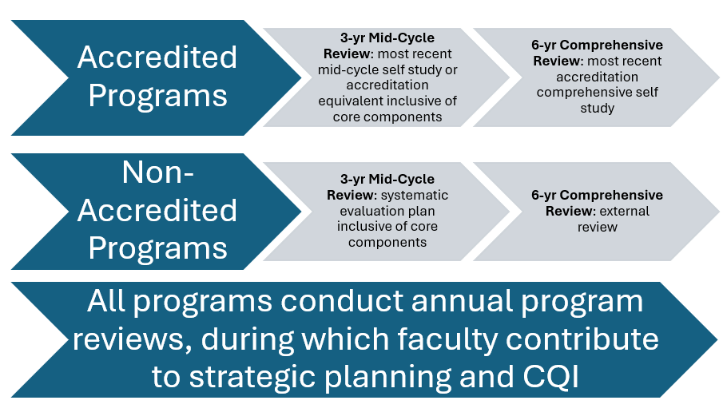

Timeline
- The comprehensive 6-year review process spans approximately 15 months from initiation to review (see Program Review Implementation Timeline for Non-Accredited Programs- Appendix E)
- Accredited programs will follow the timeline indicated by their accrediting body

Program Review Committee Structure

Internal Review Committee
- Program Faculty (possibly 3-4 members; numbers may be less or more- dependent on program): Including academic department head (ADH)/program coordinator or designee, faculty, and assessment committee member.
- Academic Affairs: Assistant Vice President of Accreditation and Academic Success (AVPAAS), Provost, and/or other Academic Affairs team members.

External Review Panel
- External Evaluators (ADH to provide 3-5 names to AVPAAS): Subject matter experts from peer institutions to visit campus and review program.

Roles and Responsibilities
- AVPAAS- The AVPAAS provides the overall coordination for the program review process with the various participants. The AVPAAS will contact the external reviewer and ensure the self-study and other related program materials are sent at least four weeks prior to the visit. The AVPAAS coordinates the site visit (in conjunction with the ADH) and receives the reviewer's report within 30 days following the visit.
- ADH- The ADH is responsible for coordinating the review of the program within their unit or may indicate a designee. The AVPAAS will meet during the spring semester prior to the program review year with the ADH and program faculty members to discuss the program review process and elements of the self-study. The program faculty members submit the self-study to the ADH who, in turn, submits a copy of all materials to the AVPAAS. The ADH will recommend 3-5 external reviewers to the AVPAAS. The ADH will set up the external reviewer’s itinerary while on campus (in coordination with the AVPAAS), including arrangements for the reviewer to visit classes and access coursework offered in any distance format.
- Provost- The Provost meets with the reviewer while on campus and makes recommendations regarding the program review to the President. Highlights of program review go to the CMU Board of Trustees (BOT).
- BOT- The BOT receives the program’s self-study, external reviewer’s report, and if relevant, the program faculty members rejoinder to the external review, as an information item (and/or highlights of the program review).
- External Reviewer- The role of the external reviewer is to provide an unbiased review of the program. The reviewer receives a stipend; they will make their travel and hotel arrangements, complete a W9 form, and are responsible for payment of taxes related to the visit. The reviewer submits their report to the AVPAAS within 30 days of the site visit.
- Assessment Committee- This committee, in coordination with the Chair of the Assessment Committee (CAC) and the AVPAAS, reviews and provides feedback on the 6-year comprehensive review, and 3-year assessment cycle components provided by the programs. The results of their review should be submitted to the ADH of the program, and the AVPAAS.

Assessment Framework and Data Collection
- Student Learning Outcomes Assessment: Programs will need to use both direct and indirect assessment measures of student learning outcomes (SLOs). Below are examples of what can be measured annually and to be included in the 3-year mid-cycle and the 6-year comprehensive report:
  - Direct Assessment Measures
Student Competency
- Curriculum map- (Appendix F) and Institution-program-course SLO-assessment alignment using Blooms taxonomy (Appendix G) for each degree level across all modes and locations and indicated assessment and metric for measurement (3-year mid-cycle and 6-year comprehensive review; Appendix H for examples).
  - Accredited programs will include documentation that shows program learning outcomes alignment (AppendixH) and/or alignment to national credentialing requirements. Accredited program’s self-studies and mid-cycle reviews can be used, if timely.
  - Programs that span undergraduate to graduate instruction will show documentation of linkage between undergraduate- and graduate-level programs and differentiation of SLO by level.
  - Accredited and Non-Accredited programs must show assessment data that speaks to the use of information and inquiry/creative competence (What is Assessment? Appendix I)
- Sample of student work across program levels; sample syllabi (following the Center for Digital Learning & Innovation Guidelines) that demonstrate intellectual inquiry and/or creative work product(s).
- Rubric-based evaluation(s) of key competencies.
- Longitudinal tracking of skill development.

Student Work (such as a Capstone or Project): Assessment and examples of course-based activities that engage students in collecting, analyzing and communicating information; in practicing modes of intellectual inquiry or creative work; and in developing skills adaptable to changing environments.
- Comprehensive final projects - includes performances and exhibition of work
- Undergraduate and graduate internship and practica experiences
- High impact practices
- Use of standardized evaluation criteria
Professional Licensure/Certification Exams
- Pass rates compared to national averages
- First-time pass rates
- Trend analysis over 3-year period
Externally Validated Assessments
- Standardized discipline specific exams
- Professional competency assessments
- Third-party skill evaluations

  - Indirect Assessment Measures
Graduate Exit Surveys
- Program satisfaction
- Perceived preparation for career/further study
- Recommendations for improvement
Alumni Surveys (post-graduation)
- Career advancement
- Application of program learning
- Program effectiveness feedback
Employer Surveys
- Graduate preparedness
- Skill gaps identification
- Industry alignment assessment
- Ability to meet program SLOs
Student Surveys
- Mid-program feedback
- Learning environment evaluation
- Support services assessment

- Program Performance Metrics: These metrics define aspects specific to your program and should be reviewed yearly with faculty:
  - Enrollment and Retention Data (yearly and trending)- some institutional data may be found on program dashboards
- Enrollment trends annually
- Retention rates by cohort
- Time-to-graduation analysis
- Transfer and withdrawal patterns
- Demographic metrics

  - Faculty Metrics
- Faculty qualifications and credentials
- Teaching load and course coverage
- Scholarship/Professional Practice/Service/Advising
- Professional development activities

  - Resource and Infrastructure Assessment
- Budget allocation and utilization
- Facilities and equipment adequacy
- Library and technology resources
- Support service availability

Program Review Process Phases

(Non-Accredited Programs)
Implementation Timeline (Appendix E)
Phase 1: Planning and Preparation (Months 1-2)
Month 1: Initiation
- Form internal review committee
- Develop review timeline and milestones
- Prepare external reviewer list
- Data collection coordination
Month 2: Data Gathering
- Compile quantitative data (enrollment, retention, graduation rates)
- Compile surveys data
- Collect assessment artifacts and portfolios
- Review previous recommendations and actions
- Draft self-study outline
- Organize assessment evidence
- Prepare materials for external reviewers

Phase 2: Self-Study Development (Months 3-9)
Program Review Self-Study Components (Appendix B)

Phase 3: External Review (Months 10-11) (Appendix J)
Pre-Visit Preparation
- Send self-study to external reviewers (at least one month prior)
- Schedule site date and visit itinerary
- Arrange stakeholder meetings
- Prepare supporting documentation
Site Visit Schedule (~ 2 days; schedule is suggested and may change with reviewer)
- Day 1: Program overview, faculty meetings, facility tours
- Day 2: Student/alumni meetings, employer interviews, data review
- Day 3: Exit interview, preliminary feedback session

External Review Report (Appendix K)
- Submitted within 4 weeks of site visit
- Assessment of program strengths and weaknesses
- Recommendations for improvement
- Commendations and concerns
- Benchmarking against peer programs

Phase 4: Response and Planning (Months 12-15)
Internal Response Development
- Review external evaluator feedback
- Faculty discussion and consensus building
- Response to recommendations
- Priority setting for improvements
Improvement Plan Creation
- Specific, measurable improvement goals
- Timeline and responsibility assignments
- Resource requirements identification
- Assessment plan for tracking progress
*Following an external review, meet with either Provost, AVPAAS, or campus equivalent to review strengths, weaknesses, opportunities, threats, (SWOT) for discussion, and create goals for upcoming next year.

Assessment Data Management
Program review (whether an accredited or non-accredited program) is not a sprint to the finish line every 6 years. It is a methodical process of collecting and reviewing data every year for a program’s review and continuous quality improvement. Program review can be captured using grids, Excel spreadsheets, surveys, and other tools. The process by which your department chooses to collect, analyze, and track program data is up to you. The goal is to have faculty involvement in the program review process- this means all faculty review collected data, analyze, and make decisions about what is working and what is not working for your program (and then indicate a plan for program improvement). Programs should include metrics for measurement, such as benchmarks or estimated levels of achievement. In discussion with the faculty, were benchmarks met? If not, what changes are warranted? This supports ongoing review of information and CQI that informs data driven changes.
Your data will provide a comprehensive picture of your program. Having a process in place (who collects, what is collected, how it is collected) and a repository to store documents will be imperative. Many programs use the systems they have available through their learning management system or Outlook program. Program dashboards created by Institutional Research will have some program specific data- see dashboard data below.

Data Collection Systems
- Student Information: Enrollment, retention, graduation data
- Assessment Management: Learning outcomes tracking
- Survey Tools: Stakeholder feedback collection, exit and alumni surveys, other satisfaction surveys
- Portfolio Management: Student work repositories; syllabi

Data Analysis and Reporting
- Trend Analysis: Multi-year comparisons
- Benchmarking: Internal benchmarking, and peer institution comparisons (as appropriate to your program)
- Disaggregated Analysis: Demographic subgroup performance
- Dashboard Data: CMU real-time monitoring tool provides:
  - Number of students by major/minor by semester/year
  - Student credit hour (SCH) by major/minor by semester/year by student type and student level
  - Course enrollment with credit hours by student type by student type and student level
  - Full-time equivalent faculty (FTEF) and full-time equivalent student (FTES); FTEF by contract type
  - Credit hours by year, department and modality
  - Course credit hour by faculty type, modality, and contract grouping
  - Degrees awarded
  - Cohort graduation rates and profile, and 4-year completion

Continuous Improvement Framework

To meaningfully support CQI, data and assessment must be collected, reviewed, and analyzed on an ongoing (at least annual) basis. Simply gathering information and completing a report- without systematically examining and acting on that information- does not constitute CQI. Using data to guide change and ensure that outcomes and metrics are met are essential elements of a genuine CQI process. This requires programs and their faculty to review gathered data yearly (direct and indirect data). Are changes warranted? How does the data influence the strategic plan of the program? Is the program aligned with university goals?

3-Year Mid-Cycle Assessment
- Accredited programs provide the most recent mid-cycle accreditation documents inclusive of core components. Non-accredited programs provide abbreviated program review, inclusive of core components (Appendix C).
- Accredited and Non-Accredited programs must show key core components inclusive of: curriculum map, assessment of SLOs and alignment to department and University SLOs, alignment to national credentialing requirements; collect/aggregate/analyze direct and indirect date; tracking and trending of data to show an action plan and/or CQI- this can best be done using a systematic evaluation plan.
- Program Assessment: Ongoing data collection and minor program adjustments (abbreviated process to comprehensive 6-year review; Appendix C).
  - Fall Semester: Data collection and analysis within your program
  - Spring Semester: data collection and analysis; review data, and create an improvement plan for CQI—for your program
  - Repeat process for years 1-5; year 6 is the comprehensive program review (See Appendix B for self-study elements)
Quality Assurance Measures:
- Internal Validation: Peer review of assessment methods. Programs should review their curriculum and assessment strategies.
- External Validation: External professional accreditation review. Accredited programs will provide accreditation self-study and external documentation. Non-Accredited programs will share self-study (Appendix B) and external reviewer report (Appendix J).
- Cross-Program Benchmarking: Programs can share institutional comparisons- programs that teach concurrent courses, online, on main campus, and other sites will show comparability of modality.
- Best Practice Integration: External research incorporation. How are programs using research to drive best practices? These are articulated through action plans, SWOT, plan-so-study-act cycles which show how data is used to inform continuous quality improvement within a program.

Stakeholder Communication
Internal Communication
- Faculty Meetings: Regular progress updates and sharing of data
- Student Forums: Feedback and information sessions. Consider program internal surveys or focus groups to elicit student feedback.
External Communication
- Alumni Networks: Progress sharing and feedback
- Industry Partners: Collaboration and input
- Accreditation Bodies: Compliance reporting
- Peer Institutions: Best practice sharing

Appendices

Appendix A
Program Review Cycle
(Comprehensive every 6 years; Mid Cycle Review every 3 years)
Accredited/Non-Accredited Programs/CMU Tech

Appendix B
Program Review Self-Study Elements (non-accredited programs)
Before the self-study begins, program faculty members should review the prior cycle review document(s) and reviewer comments for context.

- Introduction and Program Overview (2-3 pages). The narrative will include:
- Program description (degrees/certificates, majors/minors, modality, duration), and unique characteristics
- Previous review comments and progress
- Mission aligned with institutional goals- program mission and its contributions consistent with institution’s role, mission, and strategic goals
- How the program's curriculum supports other majors/minors and general education requirements, as applicable
- Regional value and comparative advantages
- Other information/data

- Curriculum (2 -4 pages). The narrative will include:
- Curriculum structure (course offerings, course sequencing, and pre-requisites)- curriculum map
- Alignment with learning outcomes and industry standards
- Use of instructional methods and technology; inclusion of best practices
- Curriculum updates and innovations
- Currency and relevance- updates reflecting latest developments, research, technologies, and best practices in the discipline AND alignment with industry/career needs, employment expectations, social challenges, and student career outcomes

- Assessment of Student Learning (6-8 pages): The narrative will include:
- Alignment of student learning outcomes (SLOs) including institution-program-course-assessment; clearly stated, measurable, and assessed
- Analysis methods and tools (direct and indirect measures)
- Analysis of student performance data (by program faculty)
- How assessment results are used for continuous quality improvement
- Student Success and Program Effectiveness (4 - 6 pages): The narrative will include (some data may come from Institutional Research and additional benchmarking):
- Direct data- capstones, final projects, creative works, internships, HIP
- Indirect data- exit/alumni/employer surveys; stakeholder feedback
- Number of majors (by concentration(s) and minors
- Registrations and student credit hours (SCH) by student level
- Registrations and student credit hours (fall and spring terms) subtotaled by course level
- Course enrollment with credit hours by student type and student level
- Enrollment trends (admission, demographics, retention)
- Graduation rates; degrees awarded
- Time to degree
- Student satisfaction and engagement
- Student post-graduation employment; licensure pass rates; graduate school acceptance
- Alumni feedback; alumni outcomes
- Stakeholder feedback/advisory board input

5. Faculty and Staff (2-4 pages): The narrative will include:
- Faculty qualifications (degrees, credentials, expertise)
- Faculty teaching load, scholarship/professional productivity, service/advising, and recognitions
- Faculty vitae
- Professional development and support
- Staff roles and contributions
- Organizational structure
- Ratio of full-time equivalent students (FTES) to full-time equivalent faculty (FTEF);
- Course credit hours and student credit hours by faculty type (i.e., tenured/tenure-track, instructor, administrators/staff/coaches, lecturers), department, year, and modality

6. Resources (2-3 pages): The narrative will include:
- Budget and funding sources (including external if applicable)
- Facilities, labs, equipment, and classrooms
- Facilities, technology, and library resources
- If equipment meets the program’s needs

7. Strategic Planning (2 pages). The narrative will include:
- SWOT analysis- consider trends in the discipline
- Input from external reviewers and previous program reviews
- Faculty analyze SLOs and program effectiveness to foster program improvement
- Action plan and recommendations (based on achievement of benchmarks)- includes responsible parties for action (improvement plan and timeline)
- Are the program’s goals being met?
- Consider return on investment/gainful employment

8. Style Guide:
The program review is read by many differing constituents, including faculty, the ADH, the AVPAAS, the Provost, and the President. Consequently, the program review needs to be easily read by a variety of groups, the majority not from departmental disciplines. Formatting also becomes important in order to meet the compilation needs of these differing groups and uses.

Please note the following guidelines as the Program Review is written in order to facilitate the preparation and dissemination of the Program Review to the above groups. Please thoroughly review before sending the document electronically to the AVPAAS.

The Program Self-Study, including the appendices, should adhere to the following guidelines:

- The text must be error-free with correct spelling/grammar/sentence structure, etc.
- All documents must be in Microsoft Word; pdfs in appendices are fine.
- The pages must be fitted to an 8 ½ by 11” sheet of paper, including all tables, graphs, assessment documents, etc.
- The documents must have 1-inch margins and use Times New Roman 12 Font throughout.
- Include page numbers.
- Any tables, charts and graphs should fit on an 8 ½ by 11 sheets of paper and be easily read. All tables, charts, and graphs should be clearly and consistently labeled both in the text and the tables/charts/graphs.
- The order found in the program review guidelines needs to be followed: Cover Sheet, Table of Contents (without page numbers), Self-Study, Appendices.
- Appendices should be included in the self-study document.
- Professional-looking resumes/CVs need to be included.
- References can only be made to sections of the Self-Study.

9. Appendices: May include:
- Course Syllabi
- Curriculum Mapping
- Assessment of Student Learning
- Example of Student Achievement
- Faculty CVs
- Assessment data and rubrics
- Program data
- Surveys and other feedback data/summaries
- External review reports

Appendix C
3-Year Assessment Template

3-Year Assessment Report Template
Due November 1st

Program Name | YY-YY

Person(s) responsible for completing and submitting this form:

An annual review of program data is critical for evaluating long-term impact, maintaining alignment with institutional goals, and supporting continuous quality improvement through evidence-based decision-making. All programs are expected to conduct yearly reviews of their majors, minors, and certificates to identify trends and convert data into actionable insights for strategic planning. This ongoing process builds a foundation of three years of data for mid-cycle reviews and six years of data for comprehensive reviews, ultimately providing a thorough understanding of overall program health.

A.
(1) Assessment of Student Learning Outcomes (SLOs) for Major, Minor and Certificate
Attach 3/6-year assessment template or similar template outlining SLOs and assessed student artifacts for program/minor/certificate.
- Include: course assessed, assignment assessed, outcome of assessment including metrics.
- Indicate: assessment cycle dates/timeline for assessment of SLOs.
- *Longitudinal tracking of skill development/benchmarking

(2) Curriculum Map
Attach curriculum map for program indicating major/minor/certificate courses that meet program SLOs. Consider creating curriculum maps where programs indicate progression of student learning using Bloom’s Taxonomy terms (early in the program- Remember/Understand; midway through the program- Apply/Analyze; end of the program- Evaluate/Create). Taxonomy progression can identify appropriate placement for artifact assessment of SLOs.

    - Indicate: alignment of course—program—institution SLOs
    - For those programs that span undergraduate to graduate instruction, indicate linkage between undergraduate- and graduate- level programs
    - Assess scope and sequencing, audit for gaps/redundancies, and ensure consistency across program
    - Use data to inform instruction- align assessment directly with SLOs
(3) Data
Attach all pertinent data- table, graphs, excel, or other created tools/tools used.
Direct Data
- To determine student competency, consider the following:
- Evaluate capstone or final projects, high impact practices, internships, exhibition of work, performance, creative works, and/or externally validated assessments.
- Multiple measurements across the curriculum/program levels.
- Rubric-based metrics of key program competencies (performance indicators)
- Professional licensure/certification exams
- *Longitudinal tracking/trending of skill development/benchmarking
Indirect Data
- Exit/alumni/employer surveys
- Mid-program feedback
- Stakeholder feedback
- Industry data/trending
- Other satisfaction surveys
- *Longitudinal tracking/trending
Program Performance Indicators
- Enrollment/retention/time-to-graduation/completion/fail-withdraw-transfer/FTES/SCH/FTEF -- by course/major/minor/certificate
- *Longitudinal tracking/trending

(4) Assessment Findings. Results/ What was Learned?
Attach any documents that support or explain findings. Indicate benchmarks as appropriate.
- Assessment of SLOs
- Curriculum Map
- Direct Assessment
- Indirect Assessment
- Program Performance Indicators
- Other Indicators, such as Industry/Stakeholder Input
- Gainful employment/return on investment¹
(5) Program Discussion
Attach any documents that support or convey program discussion.
Academic Year:
Summary of Faculty Observations

Outcomes Discussed

Evidence Referenced

Conclusions Reached

- Reflection & Continuous Quality Improvement
Attach any documents that support and/or further examine the continuous quality improvement process for your program.
Academic Year:
Actions Planned or Taken. How are findings being used? | Click or tap here to enter text.
Follow-up Plan. How will impact be reviewed? | Click or tap here to enter text.
Additional Notes or Resources needed (optional) | Click or tap here to enter text.

B.
Directions and Questions to Consider for Categories Above:
(1 & 2) Assessment of SLOs and Curriculum Map
- In determining assessment of SLOs, consider:
  - What specific question do I want to answer about student learning this year?
  - What assignments or activities best show the specified learning outcome?
  - How will you know if students are truly “getting it?”
  - What work best shows what students can do or understand?
- In reviewing and updating your curriculum map, consider:
  - What gaps and overlaps exist?
  - Is the sequencing of courses appropriate?
- Overall, consider:
  - When will we collect and review the data? (Fall semester? End of Spring? During a retreat?)
  - Who needs to be part of this process for it to work well?
  - What does success look like?
  - How will we discuss and share the results within the department?
  - How will we use the findings to make changes or improvements later?
(3) Data
- Indicate the direct measures used to assess the SLO(s). Include:
  - The question(s) you want to answer about student learning
  - Courses in which assessment occurred
  - Faculty involved in teaching or scoring
  - Assessment tools or methods (e.g., signature assignment, exam question, project, performance)
  - Rubric or scoring criteria, if used
- Indicate the indirect measure used:
  - Are you gathering the correct information?
  - What else do you want to know?

- Show the program performance indicators:
  - What does the data tell you about major, minor, certificates in your program?

(4) Assessment Findings
What do the results tell you? What evidence has led to decisions which result in improved student learning?
- Did students meet expectations?
- Strengths and challenges you observed
- Whether the success criteria/benchmarks were met
- What you learned about student learning
- How you know students are meeting (or not meeting) the SLO(s)
- How assessment findings were discussed and information shared within the Program
- What data informs changes/actions to the program and curriculum? What else should be considered?
- Consider data that shows gainful employment and return on investment for educational field¹

(5) Program Discussion
- Summarize faculty insights that have influenced improvements to student learning. Include:
  - Group contribution
  - Observations about student strengths and areas for improvement
  - Differences across sections, instructional modalities, or student cohorts, if relevant
  - This section demonstrates faculty engagement and professional judgment
- Summarize discussions that took place at department meetings, retreats, or committee meetings that have influenced improvements to student learning. Include:
- The outcome(s) discussed
- Evidence references (e.g. student work, scoring trends, teaching experiences)
- Key discussion points
- Conclusions reached
- Actions agreed upon
- This section documents collective thoughts and shared decision-making

(6) Reflection & Continuous Quality Improvement
What have you learned to make improvements? Describe what your program plans to do based on your findings. This is a space to highlight and document the work you are doing in your department and how you are continuously improving. Include:
• What changes or actions you’ll take (if any). Possible Actions include:
- Curricular revisions (content, assignments, outcomes)
- Pedagogical changes (instructional strategies, scaffolding, feedback)
- Course sequencing or prerequisite adjustments
- Faculty coordination, calibration, or professional development
• Evidence that supports your decision
• Resources or support you might need
• Plans for follow-up or reassessment
Additionally, follow-up on prior years’ plan(s):
- What changes have you made based on past assessments? What have you observed?
- Were planned changes actually started or finished?
- What progress or new evidence do you have?
- Do you need to keep monitoring, adjusting, or do you need to make new improvements?

¹ Keep in mind that the Department of Education requires career training and degree-granting programs to demonstrate that their graduates earn more than comparable workers in the same field who hold only a high school diploma within their state. In addition, graduates of advanced degree programs must earn more than the average bachelor’s degree holder in that field.

Appendix D
Systematic Evaluation Plan

 | IMPLEMENTATION
Evaluation Criteria |  | Expected Outcome | Evaluation Data (Evidence) | Responsible for Collection & Analysis | Collection Schedule | Actual Outcome | Action Plan | Action Result | Location of Evidence Document
Accrediting Agency Criterion-if applicable | Other Criterion- as applicable
PROGRAM ADMINISTRATION
PROGRAM METRICS
CURRICULUM

LEARNING OUTCOMES / ASSESSMENT

FACULTY / STAFF
PROGRAM OUTCOMES

RESOUCES / SUPPORT
STRATEGIC PLANNING

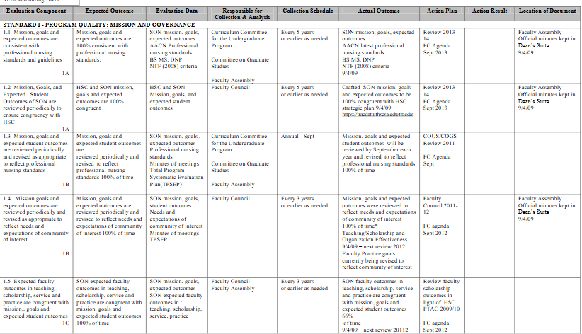

Appendix E
Program Review Implementation Timeline
Non-Accredited Programs
Phase | Timeline | Key Activities | Responsible Parties | Deliverables
Planning | Months 1-2; February prior to 6-year review | Committee formation, data collection | ADH creates internal committee | Review plan, data inventory; AVPAAS meets with ADH and program team
Self-Study | Months 3-9; mid-October self-study due to ADH; 11/1 ADH submits to AVPAAS | Report writing, analysis | ADH and faculty | 6-year self-study report
External Review | Months 10-11; mid-November external reviewer identified | Determine external reviewer and site visit dates | ADH; AVPAAS | Site review dates; site reviewer
Response | Months 12-15; January-April site visits; May-Board of Trustees reviews highlights | Evaluation, Planning, and goal setting | External Panel and internal committee | External review; prepare rejoiner (if needed) within 10 days of reviewer’s report
Program continues with yearly CQI | Yearly program review internal within programs- as noted in 3- and 6-year reports | Programs add to their program review yearly- data tracking and trending with discussion of strategic planning | ADH and faculty | 3-year template-mid cycle  6-year comprehensive report

Appendix F
Curriculum Map Examples
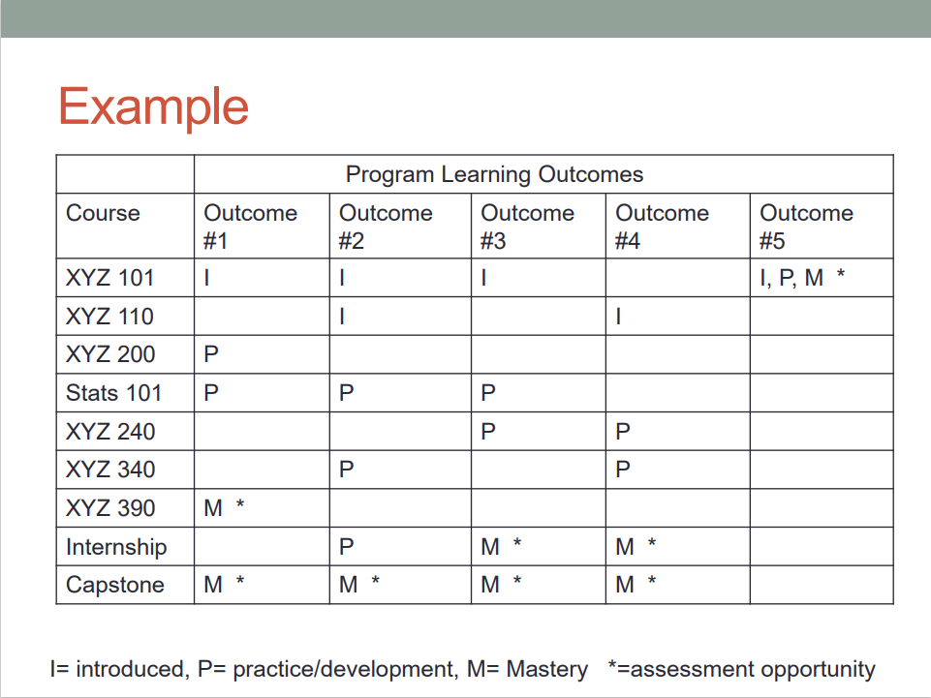
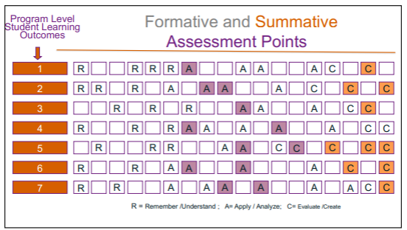

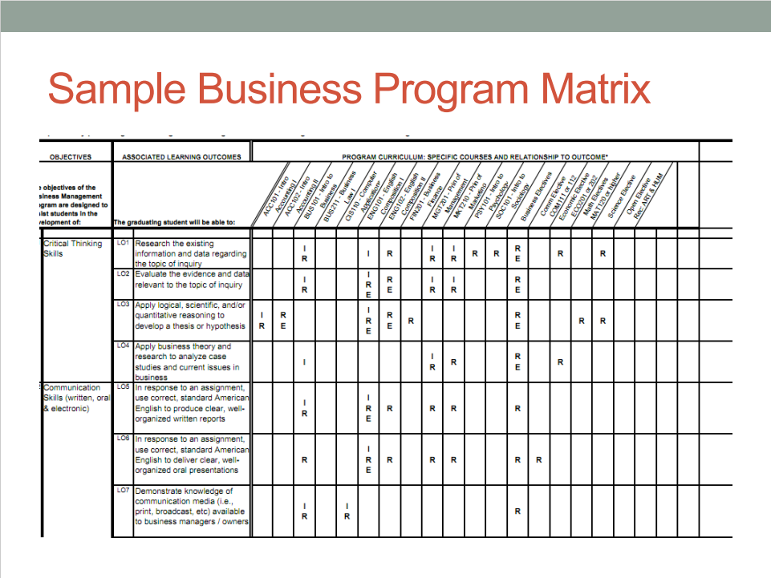
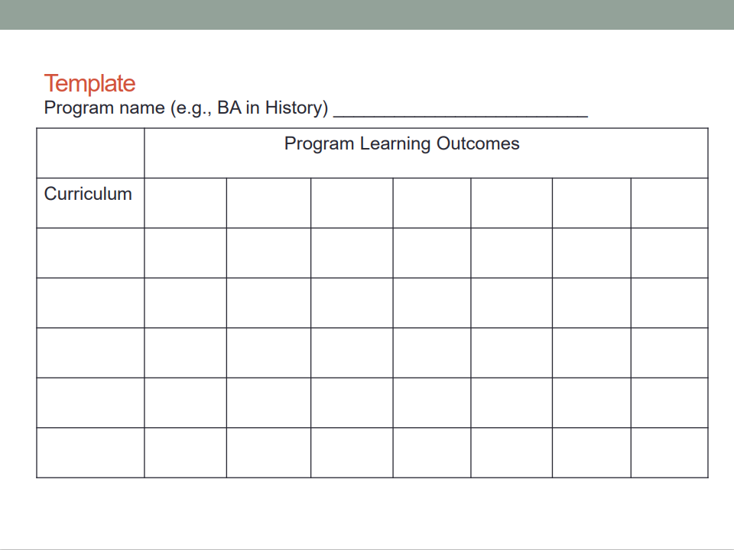

Appendix G
Blooms Taxonomy
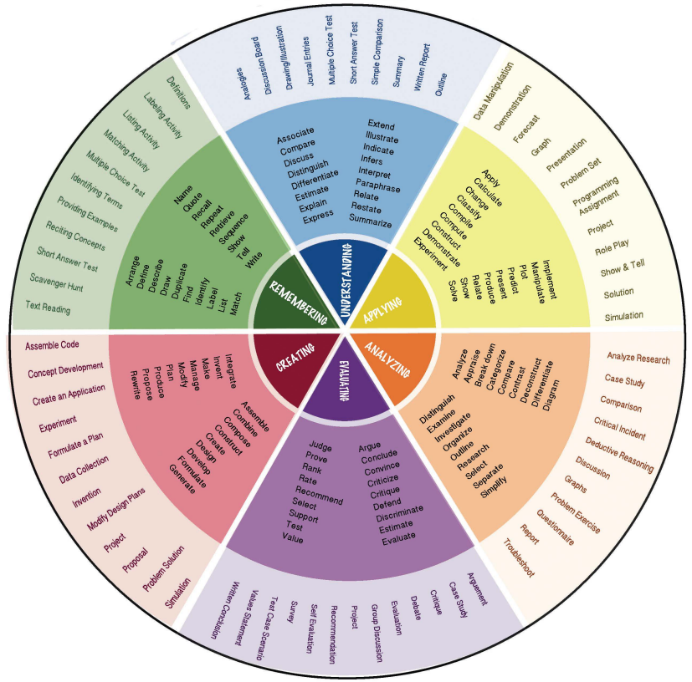

Appendix H
SLO-Assessment Alignment Examples
3 and 6 Year SLO Summary Form
Or Examples:
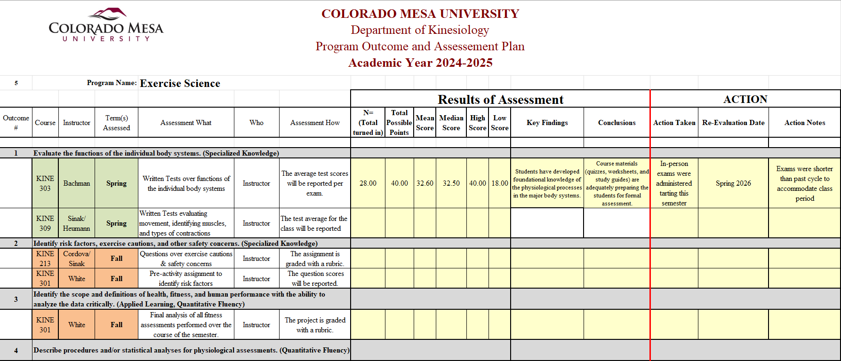
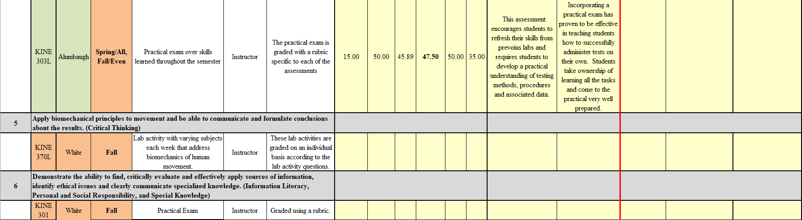

Appendix I
What Is Assessment?

1. Reframing Assessment from Bureaucratic Burden to Faculty Tool
- Acknowledge the elephant in the room: Faculty often see assessment as paperwork for accreditors.
- Flipping the frame: Assessment isn’t about compliance; it’s about clarity. It helps us articulate what we most value at CMU in our teaching and determine with evidence whether our students are actually getting there.
- Connecting to professional identity: Assessment is what good teachers already do—reflect, adjust, and improve. The work of the Assessment Committee is simply a formalization of that reflective process so it can inform decisions across the university.

2. Why It Matters—for Students
- Assessment provides a feedback loop that helps us see where students are thriving and where they’re struggling.
- It supports equity and transparency: every student deserves to know what success looks like and how their learning connects to broader goals.
- Articulated concrete Programmatic examples can show students how assessment works in practice for them.

3. Why It Matters—for Faculty
- Assessment results are evidence for teaching effectiveness, useful for tenure and promotion.
- It allows departments to advocate for resources—data showing unmet needs or successes carry weight with administration.
- It encourages cross-disciplinary conversation about what works, building a stronger academic culture rather than siloed teaching.

4. Why It Matters—for our Institution
- CMU’s credibility with students, parents, and accreditors depends on showing that learning outcomes aren’t just opinions or words on a website.
- Assessment helps CMU tell its story—to legislators, donors, and the public—as an institution that knows what it does well and cares about student demonstrable outcomes.
- Accreditation agencies (Higher Learning Commission, HLC) increasingly expects closing the loop—showing how evidence leads to change. This positions CMU as proactive rather than reactive.

5. The Emotional Hook: Confidence and Value
- Students and families invest time, money, and trust in CMU. Transparent and visible evidence of assessment gives them confidence that their education is meaningful and rigorous.
- Assessment isn’t just about measuring learning—it’s about ensuring the promises we make to our CMU students are kept.

6. The Call to Faculty
- The Assessment Committee invites collaboration rather than compliance: “Help make CMU’s assessment process something that works for us, not something done to us.”
- Faculty are encouraged to share specific examples with evidence of how they’ve used assessment to improve student learning or redesign courses.
- The Assessment Committee is here to support—not audit—departments.

Appendix J
The External Review

Selection of the External Reviewer
The ADH will provide the AVPAAS with a list of 3-5 potential external reviewers. The ADH can work with their faculty to create the list. The factors considered in selecting a reviewer may include:

- No prior connection to the CMU/Tech program or any of its faculty members.
- Experience at an institution similar to Colorado Mesa in its role and mission, program mix, and size.
- Experience as a program review consultant for other institutions’ programs.
- Involvement in the program's professional organization(s) or a professional organization aligned with the discipline.
- Experience in delivering coursework via distance delivery, preferably in an online format.
- Consider the following characteristics: worked at multiple institutions (may or may not be an important factor), tenured or senior faculty, gaining exposure to current, curricular and educational approaches within a program; administration experience at program or department level.
- Active teacher-scholar in the discipline.

Appendix K
External Review Report
Narrative
The external reviewer’s final report should assess the overall quality of the program(s) based on the self-study report as well as observations and conclusions from meetings with the ADH, program faculty members, students, alumni, administration, and other stakeholders as appropriate. The reviewer should identify “best practices” employed by the program as well as evidence of student learning and quality found in students’ work, such as in portfolios or other projects. Weaknesses/challenges identified in the program and strategies the program faculty members might take to address these elements also should be part of the narrative.

The reviewer’s report should be limited to the topics outlined in Appendix B and not discuss topics unrelated to programming qualities. The final report, including the executive summary (Table 1), should be received by the AVPAAS no later than 30 days following the campus visit; The AVPAAS will distribute to the Provost and the ADH. The reviewer’s recommendations for program improvement should be prioritized either from most important to least or grouped according to short-term vs. longer-term improvements. Program faculty members and the ADH may submit a rejoinder to the reviewer’s report, if desired, within 10 days of receiving the reviewer’s report. Payment for the external reviewer occurs once the agreed upon initial report is received and approved.

The State of Colorado views external program reviewers as consultants who receive a flat-rate payment which includes all travel-related expenses. The reviewer's cost is paid by the Office of Academic Affairs.

Executive Summary
- Tabular Form
Table 1 presents an executive summary of elements to be completed by the reviewer in addition to the report's narrative.
- Recommendations
- List the 3 - 5 recommendations for program improvement of highest priority. What is the most important improvement this program needs to make during this review cycle, within the context of limited resource availability?
- What are the most exemplary element(s) about this program?
Table 1: Executive Summary Template for External Reviewer’s Observations

Program Review Element | Check the appropriate selection |  |  |  | Provide explanation if not agree with element and/or why unable to evaluate
Program Review Element | Agree | Not Agree | Unable to Evaluate | Not Applicable
The program’s self-study is a realistic and accurate appraisal of the program.
The program’s mission and its contributions are consistent with the institution's role and mission and its strategic goals.
The program’s goals are being met.
The curriculum is appropriate to the breadth, depth, and level of the discipline.
The curriculum is current, follows best practices, and/or adheres to the professional standards of the discipline.
Student demand/enrollment is at an expected level in the context of the institution and program’s role and mission.
The program's teaching-learning environment fosters success of the program's students.
Program faculty members are appropriately credentialed.
Program faculty members actively contribute to scholarship, service and advising.
Campus facilities meet the program’s needs.
Equipment meets the program’s needs.
Instructional technology meets the program’s needs.
Current library resources meet the program’s needs.
Student learning outcomes are appropriate to the discipline, clearly stated, measurable, and assessed.
Program faculty members are involved in on-going assessment efforts.
Program faculty members analyze student learning outcome data and program effectiveness to foster continuous improvement.
The program’s articulation of its strengths and challenges is accurate/ appropriate and integral to its future planning.

