CMU Assessment Committee

Meeting Minutes from 10 a.m. - Sept 1, 2023 - DH 312 Board Room

- Discussed TASKS to progress for next meeting Shown in Red

Present in person (x); Present via zoom (y); Not present (z)

Greg Baker x
Beth Branscum x
Morgan Bridge (exofficio) x
Patrice Connors x
Adrian Herrera Escobar x
Suzie Garner (exofficio) y
Geof Gurka x
Jessie Hawkes x
Happy Katzer y
Eric Miles x
Laura Muñoz y
Chris Penick x
Lisa Friel-Redifer y
Ben Reigel x
Jeremy Tost (exofficio) x
Kristin Santos x
Elizabeth Sharp z

The agenda for this meeting

- Rollcall and review/approve minutes from the 5/05/23 meeting

- Motioned (Elizabeth) and seconded (Kristen).

- Welcome to a new year and introduction of new members (including the role and mission of the Assessment Committee) for the purpose of:
  - informing the new members
  - reinforcing with returning members

Chris Penick (re)introduced the Assessment Committee to set the stage for the new academic year. The following excerpts presented to the group are from the “Student Learning Assessment Handbook” (https://www.coloradomesa.edu/assessment/documents/assessment-handbook.pdf)

Assessment Overview
- Assessment is the ongoing process in which student learning outcomes are defined, student success in achieving those outcomes is measured, and the results are used to implement improvements in curriculum.
- Thus, the overarching purpose is to gauge what students have learned in the context of program/course expectations and then document the resulting enhancements to program/course delivery.
- Most faculty members do this on an on-going basis, though perhaps not documenting formally or done in concert with other faculty members.
- A key consideration in the process is that the student learning outcomes data that are collected are meaningful to those faculty members involved in the instruction, and the assessment process is manageable for all who participate.
- Elaborate plans that are not implemented and/or result in feedback that doesn’t benefit a faculty member’s efforts are of no value in this context.

- There are three stages to an effective outcomes assessment program:

  - Define the important skills for students to achieve when participating in an academic experience (outcome);
  - Evaluate how well students are achieving those skills (assessment); and,
  - Discuss and use the results for program improvement (closing the loop).

- Often the first two stages are accomplished and data is gathered without using it for program improvement, or the information is not recorded and there is no history to determine why changes were made. A good assessment program can demonstrate high quality student learning and program effectiveness for all University’s constituents.

Who Benefits from Assessment?

- First, and foremost, students benefit from assessment since student learning outcomes provide clear expectations about what is important in the program or course. Program improvements based on assessment can help students in their learning experiences.
- Second, faculty benefit because assessment helps determine what is and is not working in the program. Assessment lends itself to writing the ‘story’ of the program and can demonstrate to interested constituencies of the institution the quality of the program. Assessment can strengthen the cohesive nature of teaching and learning.
- Third, administration benefits when the assessment process demonstrates institutional commitment to continuous improvement of academic and student support services. Valuable information is also shared with state and local governments, or private supporters when requesting funding. Results of assessment can be easily shared with the University’s stakeholders and demonstrate the impact that education has on students and community.

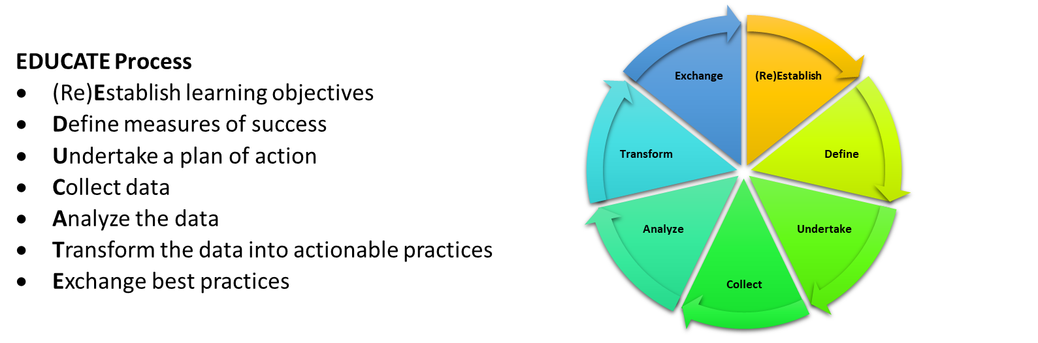

Discussion

- Some modifications/additions of Assessment website needed—EDUCATE graphic, Overview “What is Assessment?” Video (Spring 2023), and perhaps other things.

- Election of officials (chair, vice-chair, secretary) including the definition of duties
  - Chair: Chris Penick (unanimous)
  - Vice Chair: Ben Reigel (unanimous)
  - Secretary: Baker (unanimous)

- Plans and direction for Assessment Committee this year (including stuff about CTL if that pans out)

  - Update web site
  - Assessment Best Practices
    - Ad hoc subcommittee (?), with the objective to:
      - Make assessment a positive mechanism. Benefits STUDENTS most of all, but also enhance the reputations of individual Programs.
      - Improve specifics of using D2L (e.g., assignments submitted in D2L for SLOs then easier to “extract” for semester assessment of ESSL SLOs, etc.)
      - Work with CTL (Center for Teaching and Learning), Kate Belknap, Director
        - Training?
        - Place to meet?
        - Broadening (outreach) of Assessment at CMU via discussions with other members of CTL?
    - Begin working through Program assessments (SLOs; 3-year; 5-year)
    - Spring 2024 groups complete Program Assessment early Spring (Feb?)

- Assessment focus (Bridge)

- Continue to work on Quantitively Literacy
  - How can Assessment Committee think about working with MATH, etc., to improve specifically on CMU campuses
  - A BIG task! Lots of room to learn—not “solved” either at CMU or the national level
- Push to continue to highlight “Closing the Loop”
  - Important to remember that this is the MAIN GOAL of all of the assessment work.
  - Continuous improvement!
- Culture of assessment on campus—link to “Best Practices” by the Assessment Campus
  - Survey?
  - Find Faculty “champions” on campus
- Higher Learning Committee (HLC) to meet with Assessment Committee, perhaps Oct 2nd which HLC members are on campus.

- New/Other Business?

- Adrian discussion of difficulties in applying the “standard” SLOs in arts/performance where there may be more subjectivity. Ad hoc committee?

Adjourned

10:50pm

