Transaction Screen for wireless device
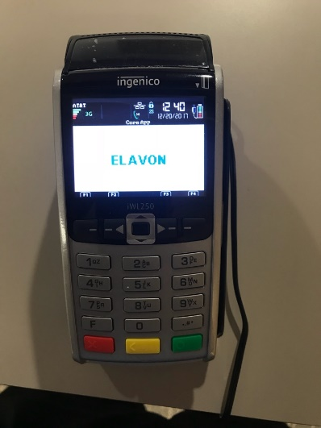
Green Button gets to main menu
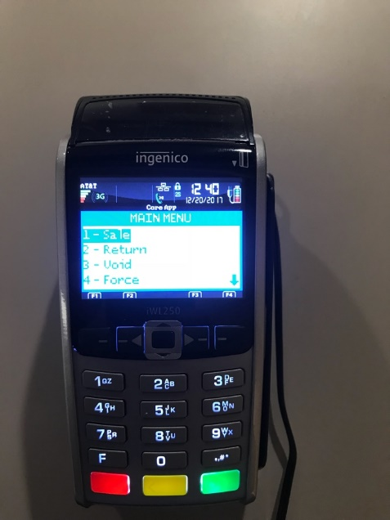
Click 1 Sale - Sale screen to enter an amount of transaction.
Green button and then it will take a few to pull up screen to swipe.
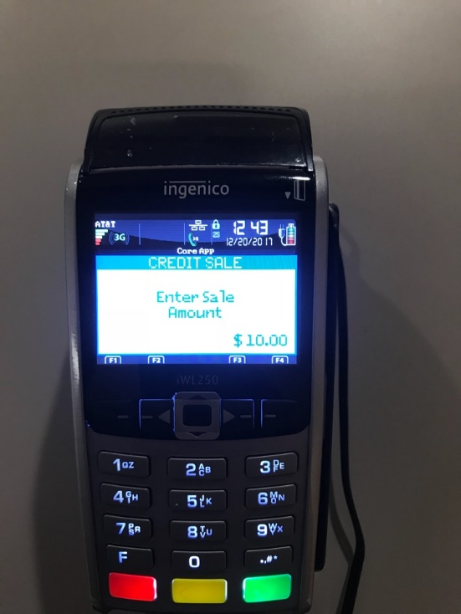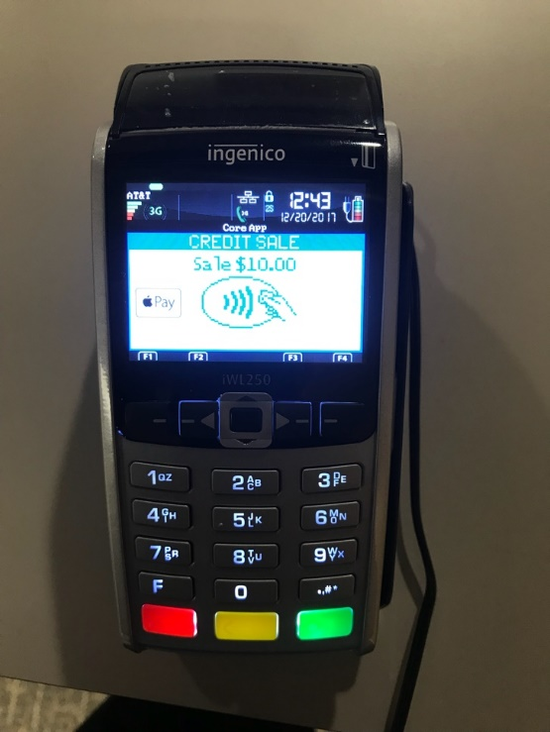

*** Keep all signed credit card receipt slips for back up on deposit.

Closing Credit Card Machine
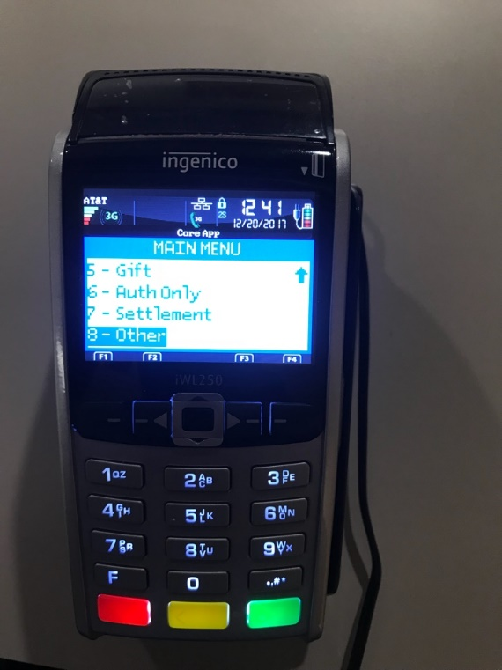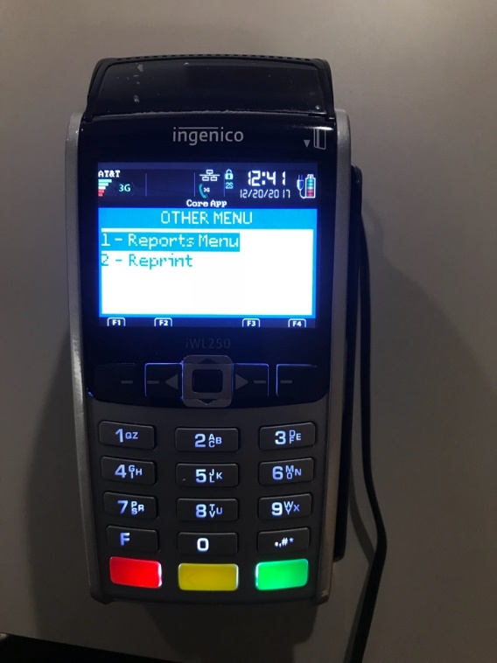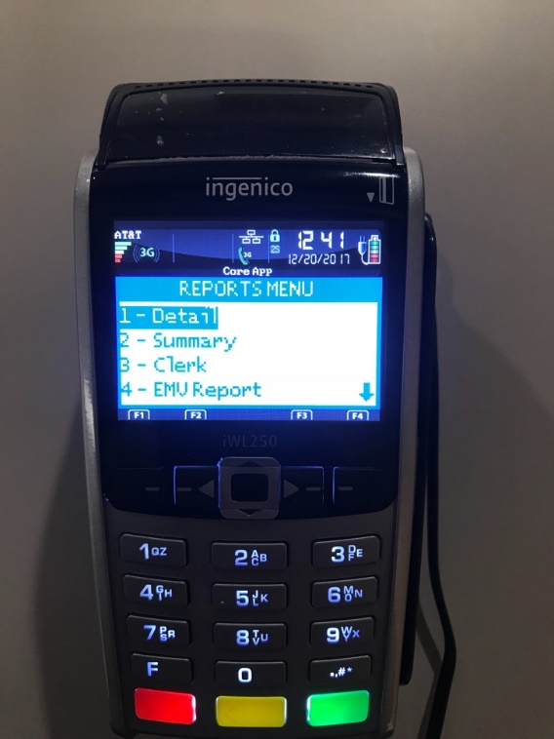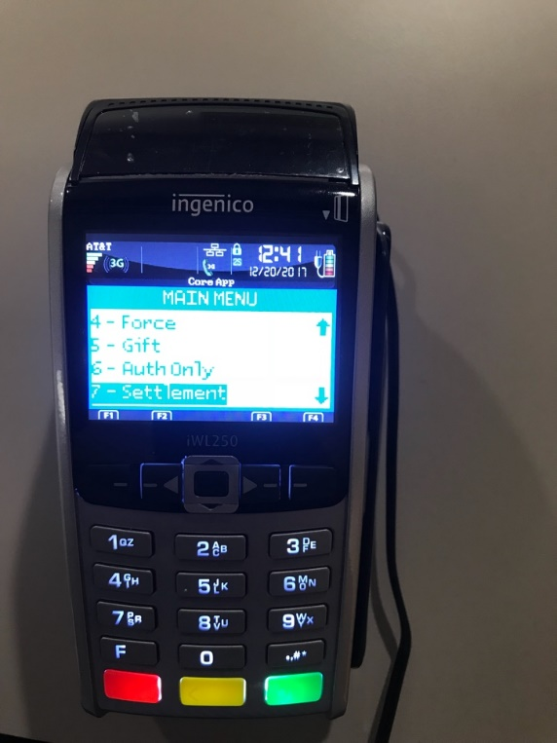
- Green Button scroll to 8 Other and click.
- Press “Report Menu”
- Press 1 “Detail” and 2 “summary” to print
Do not separate the two reports as they print, just run a continuous tape.
- Sort sales slips to match the order shown in Detail Report.
- Add the individual sales slips together once they are in order to get a total
- Verify that the total matches the Summary Report. If the total of the slips does not match the Summary Report, check each receipt against the items on the Detail report. The total must match! Reprint any missing slips.
- To reprint missing slips:
- Press “2 Reprint” on the “Other” menu
- Last receipt or Any receipt and enter number in the batch of the receipt
When you are ready to close the machine,
- Press 7 “Settlement” on main menu.
- Yes to close batch and accept that the totals equal!
- Circle “GBOK############” on the Settlement Report towards the top.
- Write your department name on the top of the Settlement Report.
Order of Paperwork (paperclip together)
- Settlement
- Reports
- Individual Receipt
To power On/Off -Hold down black middle button. The machine must be off charger to power off.

