Transaction Screen for Wired device
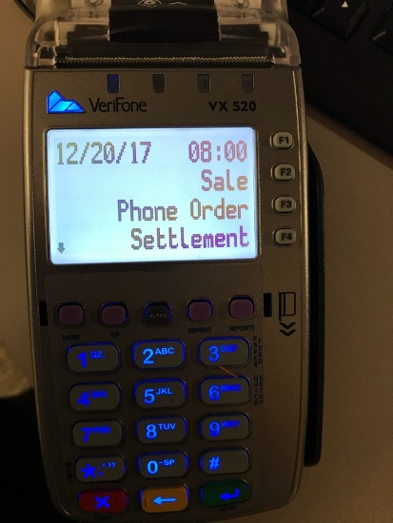
F2 – Card
F4 – Closing Settlement
1) Select F2 to get to the sale screen
2) Enter an amount.
3) Gives confutation screen for “yes and no” on correct total. Select Yes
4) Either enter card #, insert chip, swipe card, or select apple pay.
* If a debit card please only choose Visa or MasterCard or Discover “Do not choose US debit”.
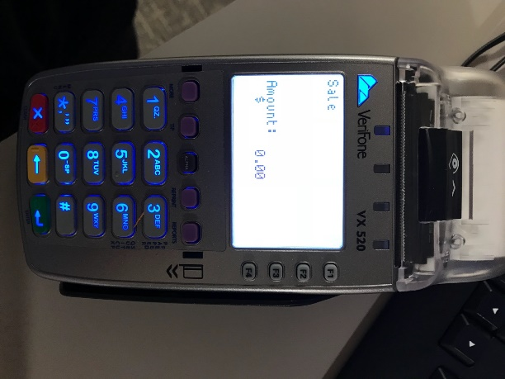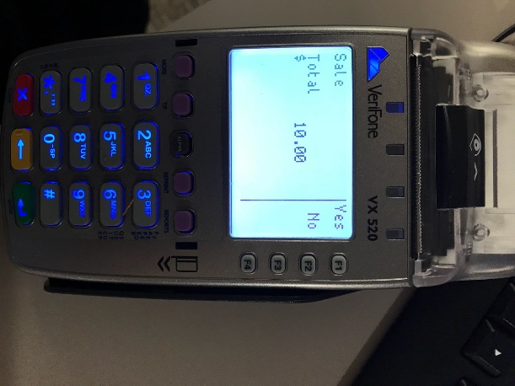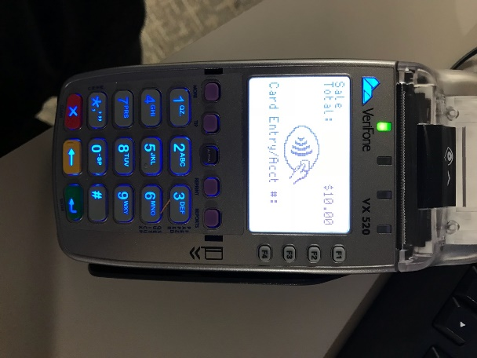
*** Keep all signed credit card receipt slips for back up on deposit.

Closing Credit Card Machine
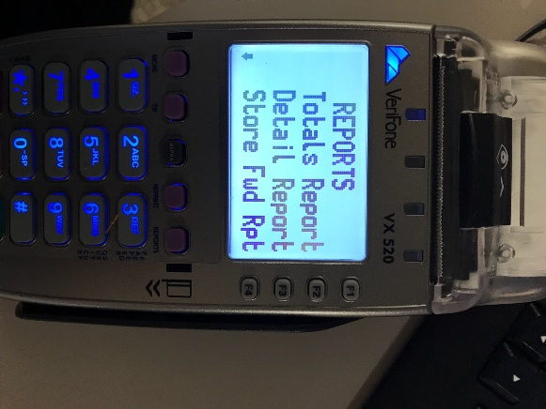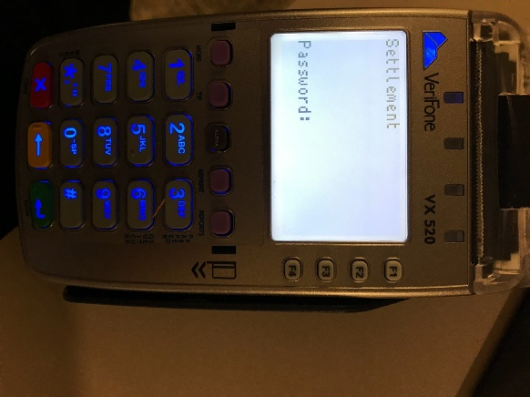
Press “Report” Left Purple Button
- Press F2 “Totals Report” and F3 “Detail Report” to print
Do not separate the two reports as they print, just run a continuous tape.
- Sort sales slips to match the order shown in Detail Report.
- Add the individual sales slips together once they are in order to get a total
- Verify that the total matches the Totals Report. If the total of the slips does not match the Totals Report, check each receipt against the items on the Detail report. The total must match! Reprint any missing slips.
- To reprint missing slips:
- Press “Reprint” Purple Button
- Last receipt or Any receipt
When you are ready to close the machine,
- Press Red back and click F4 “Settlement”
- Enter Password: 16682 and press green button.
- Sales totals on the screen should read the same as on the Batch Totals.
- Circle “GBOK############” on the Settlement Report.
- Write your department name on the top of the Settlement Report.
Order of Paperwork (paperclip together)
- Settlement
- Reports
- Individual Receipt

