D2L/Brightspace: Student Pairing for Inclusive Access
(HOW TO GET ALEKS SET UP IN D2L)

To pair your LMS account with ALEKS, follow the steps below.
- Log into your D2L account.
- Select your course.
- Select Content.
- On the left side navigation, select ALEKS, and then select the External Learning Tool ALEKS | McGraw Hill. (Note, the name of the module and tool link for ALEKS may be different depending on each instructor or school.)
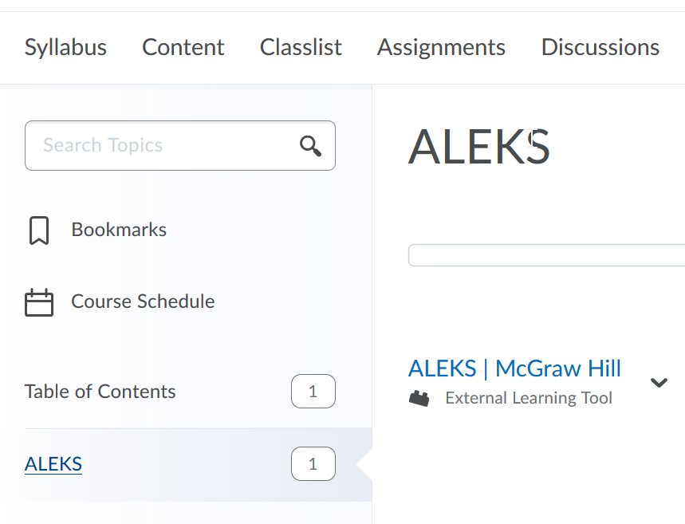

- If you have never used ALEKS, select the first option, No, I have never used ALEKS before and then select Continue. If you already have an ALEKS account, select Yes, I have an ALEKS login name, enter your login information, and then select Continue.

(Basically everyone should do the NO option, If you have used ALEKS as a placement that would still be a NO, my understanding is once you are set up you will not need to know your login and password it will be automatically paired with D2L and it will be just as if it is part of D2L)
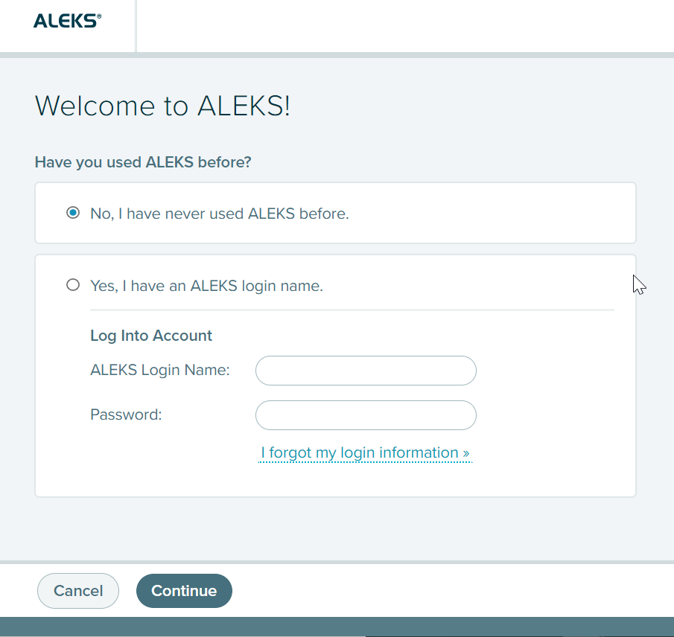

- Verify your information, accept the Terms of Use, and select Continue. (The example below is for new user registration.)

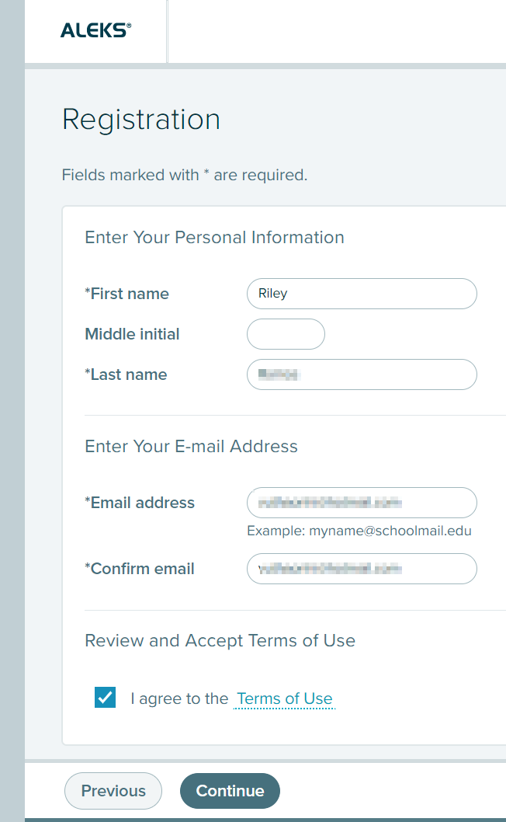

- Your account is now paired with ALEKS. Select Continue.
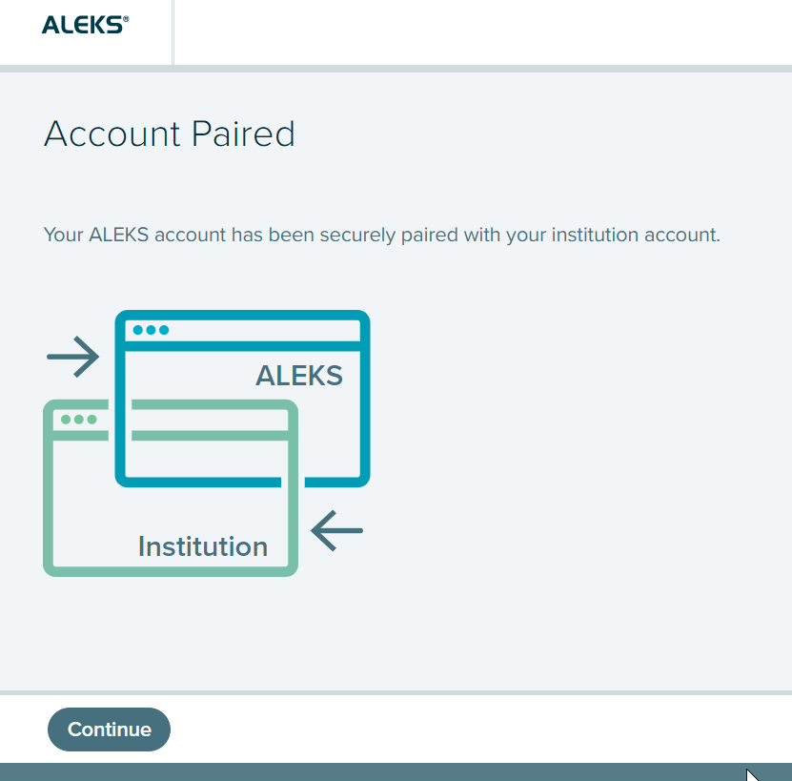

- You are now in your ALEKS Student Account Home.
