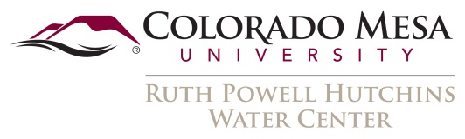

Summer 2024 Student Water Research Grant Program
Request for Proposals
Program Description
The Ruth Powell Hutchins Water Center at Colorado Mesa University seeks proposals for student research projects related to water resources on Colorado’s Western Slope. The program is open to all disciplines, including, but not limited to, the humanities, social sciences, and natural sciences. Proposals must have a faculty advisor and students must be enrolled full-time in a degree program at Colorado Mesa University. The research must be directly relevant to water issues in the Upper Colorado River Basin in Colorado, including any watersheds that are tributary to the Colorado River. The award will be administered by the CMU office of sponsored programs.
Funding
The award is limited to a maximum of $5,000. Project budget may include student salary, fringe benefits, supplies, services, travel, and other direct costs. Up to $1,000 of the budget may be dedicated to salary for the faculty supervisor. Only direct costs are allowed for this research grant. Projects may begin no earlier than May 20, 2024 and must be completed by December 31, 2024.
Eligibility
Students must be enrolled full-time in a degree program at Colorado Mesa University through December 31, 2024. Proposals must have a CMU faculty advisor. The faculty advisor is responsible for ensuring that the proposal has been processed according to CMU’s proposal submission policies and procedures.
Submission Process
Proposals must be submitted as a word document via email to fwitarsa@coloradomesa.edu by April 19, 2024. Please see coloradomesa.edu/water-center for detailed proposal guidelines. Proposals must be submitted using the student proposal form and may not exceed 5 pages.
Announcement of Awards
The student applicant and faculty advisor will be notified as to the status of their application by May 10, 2024 via email. Projects may not be started until official notification of funding is received.
Deliverables
Upon completion of the project, the recipient will be required to submit a report that includes a narrative describing research activities and project results, photos of the student and faculty advisor conducting research for the project, and complete financial accounting of all expenditures. Final project reports may by published by the Hutchins Water Center as part of a report series. Students or faculty advisors may be invited to present an oral or poster presentation on their work at the next Upper Colorado River Basin Water Forum.
Program Contact Information
Freddy Witarsa, Associate Professor, Colorado Mesa University, fwitarsa@coloradomesa.edu

