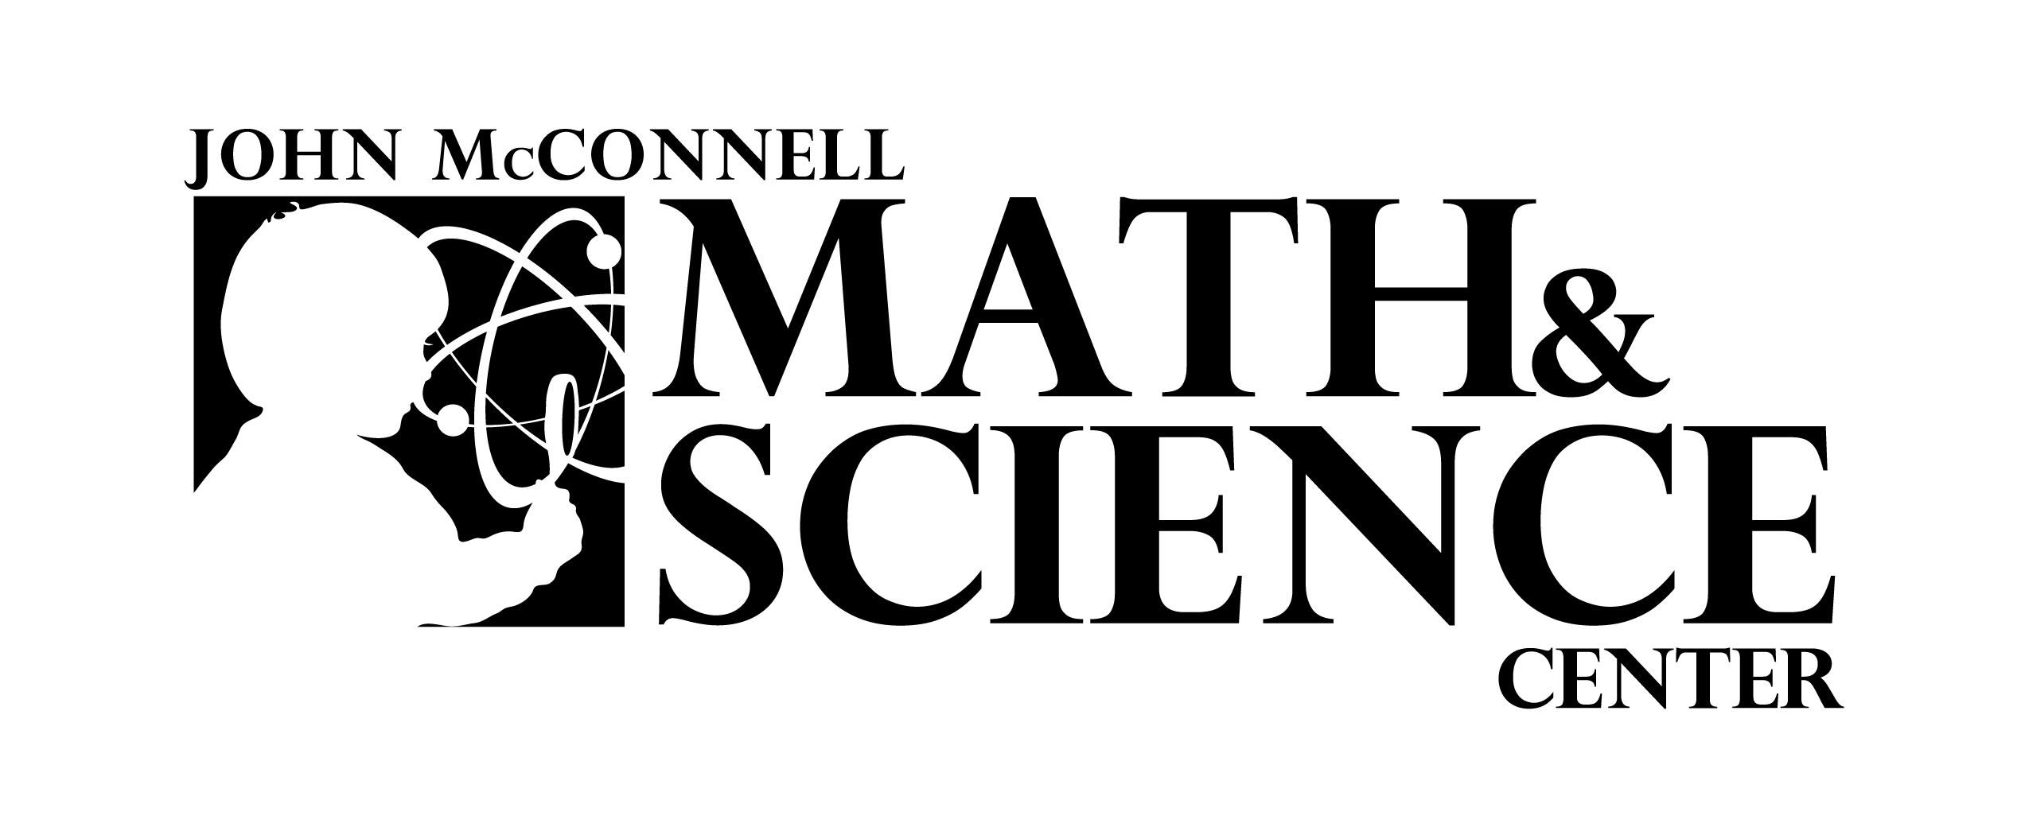

Look – Explore – Understand

[www.MathandScienceCenter.org](http://www.MathandScienceCenter.org)

2660 Unaweep Avenue Grand Junction, CO 81503

Phone: 970-254-1626 Fax: 970-245-2664

**MEDIA ADVISORY**

**FOR IMMEDIATE RELEASE: February 27, 2011**

**John McConnell Math & Science Center and the Water Center at Colorado Mesa University host “What’s Happening with Our Climate (in Western Colorado)”, a presentation by Nolan Doesken, State Climatologist, Colorado Climate Center at Colorado State University**

Because of its latitude, altitude (highest average altitude in the United States), and complex topography, Colorado’s climate is highly variable and changes dramatically from year to year. Climate basics (i.e., factors that influence climate like latitude, elevation, air mass characteristics, distance from moisture sources, etc.) will be discussed with respect to the state as a whole and how different Grand Junction is compared to the mountains and the Front Range urban corridor.  Doesken will emphasize how the climate, as we've observed it over the past 100+ years, has varied and how that has affected water supplies, fruit growing, and other economic drivers in Colorado. Finally, he will show what some climate models anticipate the next several decades to look like.

Nolan Doesken is a life-long weather watcher and has worked for nearly 35 years at Colorado State University monitoring and studying the remarkable and diverse climate of Colorado.  He serves as State Climatologist at the Colorado Climate Center at CSU in Fort Collins.  He is also Director of the historic Fort Collins weather station that has been tracking daily weather without interruption for 125 years.  Doesken is also the founder and national director of the Community Collaborative Rain, Hail and Snow network -- a program that encourages people of all ages to help scientists track precipitation patterns across the country. He is the recipient of the 2011 President's Award from the Colorado Foundation for Water Education in recognition of his advancement to greater understanding of Colorado’s climate and water resources.

Teresa Coons, Math and Science Center Executive Director, said, “We are so excited to be able to host a speaker with Nolan Doesken’s credentials at the Math & Science Center. In addition to his tremendous knowledge about the Colorado climate and its impacts on our way of life, I understand that he is a very engaging and interesting speaker!”

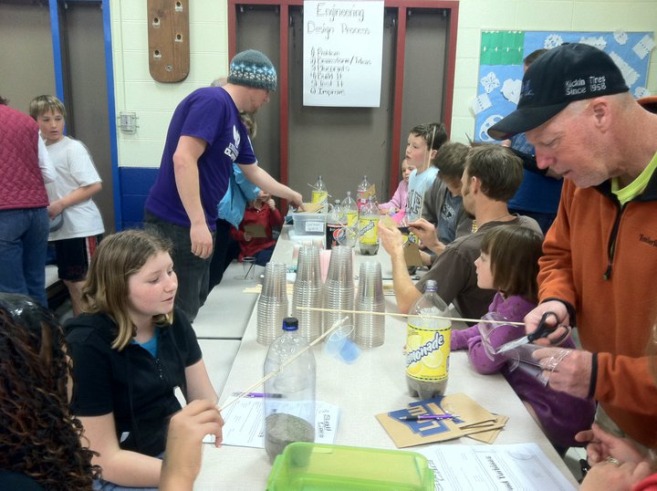

**Details:**

**Where: John McConnell Math & Science Center, 2660 Unaweep Avenue (in New Emerson Elementary School)**

**When: Wednesday, February 29, 7 – 9 PM**

**Cost: No charge**

**About *The John McConnell Math and Science Center of Western Colorado***

The John McConnell Math and Science Center, located in New Emerson School on Orchard Mesa, is striving to address the critical need to prepare students for careers in science and technology in the 21st century. Through interactive displays, inquiry-based lessons and demonstrations and other forms of hands-on learning, the Center allows students of all ages to engage with a wide range of math and science subjects. These experiences enlist their natural curiosity and expand their excitement for learning and applying knowledge about the scientific world. The Center also serves teachers by helping them develop resources and new ideas to enhance their classroom teaching capabilities. In addition to the Center’s displays and exhibits for visitors, the Center conducts classroom outreach around the Western Slope of Colorado. The Center is a non-profit, 501(c)3 organization that is funded by generous grants, gifts from individuals, fees and partnerships. For more information about the Center or about upcoming *Family Science Nights* and other events, visit our web page at [www.mathandsciencecenter.org](http://www.mathandsciencecenter.org).

**About *The Water Center at Colorado Mesa University***  
The Water Center at Colorado Mesa University is a joint project of the Mesa County Water Association (MCWA) and Colorado Mesa University. The Mission of the Water Center is to perform and facilitate interdisciplinary and collaborative research, education, outreach, and dialogue to address the water issues facing the Upper Colorado River Basin. The Water Center recently hosted its *Annual Water Course*, designed to help local water users, civic leaders and interested citizens understand local water issues. For more information, please contact Hannah Holm, Center Coordinator at 970-248-1968 or visit watercenter@coloradomesa.edu.

**Contact: Teresa Coons, Executive Director**

**John McConnell Math & Science Center of Western Colorado**

**970-254-1626**

[**tcoons@mathandsciencecenter.org**](mailto:tcoons@mathandsciencecenter.org)

[**www.MathandScienceCenter.org**](http://www.MathandScienceCenter.org)