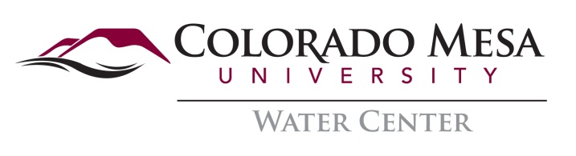

Value of the Colorado River to Western Colorado Economies

Hosted by the Mesa County Conservation Forum, Colorado Mesa University Water Center, Protect the Flows Project

Opening Comments by Al White Colorado Tourism Office Director, Denver

Steve Acquafresca, Mesa County’s Director to the Colorado River Water District
Tom Kleinschnitz, Adventure Bound Outfitters, Club 20 Tourism Chair
Max Schmidt, Manager, Orchard Mesa Irrigation District
Kurt Mill, Regional Manager, Colorado Parks & Wildlife
Bruce Talbott, Local Grower and representative of local growers

Moderator: Hannah Holm, CMU Water Center

Join in the dialogue about how many different uses of the Colorado River impact our local economy.

Tues May 22nd 6-8:00pm CMU Center Ballroom

