Colorado Watershed Restoration Program Grant Application
(Stream Management Plan Category)

Project Summary Sheet

Project Title: Colorado Basin Roundtable Integrated Water Management Planning Framework
Project Location: Colorado River Basin within Colorado
Grant Type: Colorado Watershed Restoration Program, Stream Management Plan Category
Grant Request: $67,947
Cash Match funding: $53,399
In-Kind Match Funding: $29,256
Project Sponsor: Colorado Basin Roundtable
Fiscal Agent: Colorado Mesa University Ruth Powell Hutchins Water Center
Primary Contact: Hannah Holm
Address: 1100 North Avenue, Grand Junction, CO 81501
Phone: 970-248-1968 (office); 970-683-1133 (cell)
Email: hholm@coloradomesa.edu

Project Description
This project will provide the informational and procedural framework for conducting comprehensive integrated water management plans in the Colorado River Basin. The purpose of these plans will be to identify ways to provide sufficient water for environmental needs while recognizing the needs of agricultural, domestic and industrial water users.

This project will include the following tasks:
- Information Gathering: An extensive review and compilation of existing information relevant to the development of integrated water management plans. The resulting compilation will be available in table form and linked to a map of the basin to show spatially which stream reaches have been studied in what ways.
- Information Synthesis: A detailed GIS map will utilize the information collected in task #1 to depict what available data shows about stream health in each stream segment in the basin.
- Stakeholder Engagement and Education: Consultation with stakeholders in order to refine the goals and objectives of the basin-wide planning effort; achieve consensus on the recommended tools and processes for developing integrated water management plans; and establish priorities for implementation. Once priorities are established, outreach will be conducted in the priority sub-basins to solicit interest in developing detailed plans.
- Develop Framework for Stream Management Planning: Drawing on the work done in tasks two and three, develop and describe a framework for the creation of integrated water management plans at the sub-basin level that facilitates the integration of discrete plans into a comprehensive tool that can be applied basin-wide.

SCOPE OF WORK
Project Sponsor: Colorado Basin Roundtable
Fiscal Agent: Colorado Mesa University Ruth Powell Hutchins Water Center
Primary Contact: Hannah Holm, 970-248-1968 (office); 970-683-1133 (cell); hholm@coloradomesa.edu
Address: 1100 North Avenue, Grand Junction, CO 81501
Project Title: Colorado Basin Roundtable Integrated Water Management Planning Framework
Grant Amount: $67,947

Introduction and Background
The Colorado Basin Roundtable (CBRT) has identified a basin-wide stream management plan (SMP) as a top priority in its Basin Implementation Plan. The CBRT feels that such planning is vital to providing sufficient water for environmental needs among the many competing uses and demands for water, and thereby restoring and protecting ecological processes that connect land and water while ensuring that streams also serve the needs of human populations.

Grand County began their SMP with a search of all the literature, studies, reports and existing management actions covering the upper Colorado River within Grand County. We propose here to follow Grand County’s example in such a way that information gathering and synthesis inform stakeholder engagement and the development of a broad yet flexible template from which comprehensive and connected plans can be developed.

The CBRT views SMPs as comprehensive in the sense that they need to consider both consumptive and non-consumptive uses, which is why we are calling this project an “integrated water management planning framework.” While tasks one and two focus on information gathering and synthesis related to environmental needs, we recognize that other work has been completed or is in the process of being updated with regard to consumptive use and needs in the basin. This body of work and its integration into a planning framework will be considered during tasks three and four, which involve stakeholder engagement and developing a framework for the creation of integrated water management plans at the the sub-basin level. This framework will facilitate the integration of discrete plans into a comprehensive tool that can be applied basin-wide. This graphic describes the overall process for this project:
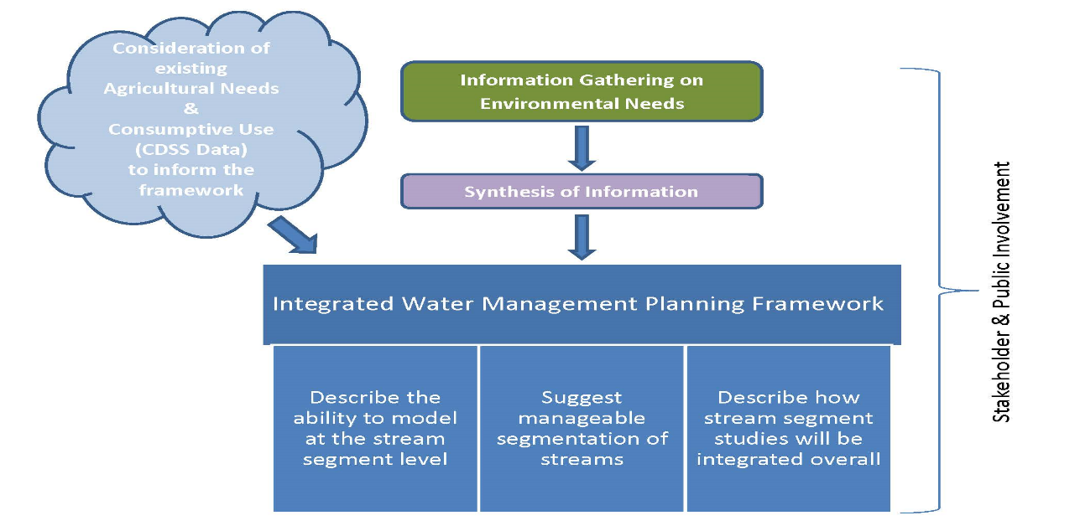

Project Objective
The objective of this project is to develop an integrated water management planning framework for the watershed area within the purview of the Colorado Basin Roundtable (CBRT). The proposed work will lay the necessary groundwork for entities to develop detailed integrated water management plans (IWMPs) that address local and/or regional needs while also providing information and output that can be used for basin-level planning and management purposes. While this proposal initially focuses on quantifying non-consumptive needs, the CBRT foresees the use of IWMP tools that integrate both consumptive and non-consumptive uses to ensure that all existing and future uses are considered.

Task 1 – Information Gathering
Description of Task: Complete a targeted review and compilation of existing information relevant to the development of IWMP tools specific to the CBRT study area. This task will focus on the collection of literature, studies, reports and documented management actions and strategies that address or can inform, in whole or in part, one or more of the following questions:
- What flows are adequate to support the life stages of the fish native to the stream segments (i.e., magnitude, frequency and duration);
- What flows are necessary to provide adequate sediment flushing;
- What flows are necessary for channel, floodplain and riparian area maintenance;
- Is the stream healthy (i.e., what do indicators such as macroinvertebrate indices, fish population data, riparian condition assessments, etc. suggest); and
- What is known about the contribution of agricultural return flows as it relates to instream flows?
Method/Procedure: The Ruth Powell Hutchins Water Center (Water Center) at Colorado Mesa University (CMU) will conduct the inventory work. Recognizing that considerable work has been completed to date with regards to literature searches in the study area, the first step will include the assembling and querying of existing inventories from the following sources:
- CBRT Basin Implementation Plan;
- Watershed Flow Evaluation Tool Report;
- CBRT Non-consumptive Needs Assessment;
- Grand County Stream Management Plan; and
- Upper Colorado River Basin Resource Guide (CMU).
Following an initial querying of the existing inventories, the Water Center will complete its information gathering through reviewing the relevant scientific journals and communication with the various watershed groups in the study area; resource management, planning and regulatory agencies; academic institutions; and local governments.
Deliverable: The inventory will be compiled in a database format with identifying attributes that include information source, applicable sub-basin or stream reach(es), and data type. This database will be dynamically linked to the web-based interface “Upper Colorado River Basin Resource Guide”, which is currently under construction and resides at the Water Center. This guide includes maps to show spatially what stream reaches have been studied in what ways.

Task 2 – Information Synthesis
Description of Task: Information collected in Task 1 will be synthesized for the purpose of identifying what is already known, what information gaps exist and where, and what resources and technical expertise will be needed to fill those information gaps. This task will go beyond task 1 by depicting what available data shows about stream health in each stream segment in the basin. This task will be undertaken in tandem with Tasks 3 and 4, recognizing the need to have a basic framework described in order to determine: 1) where existing information is adequate and appropriate and 2) what types of additional information are needed and at what level of detail.
Method/Procedure: From the inventory compilation, a contractor will extract, interpret and categorize information relevant to the five questions posed in Task 1. Results will be displayed and examined spatially to develop a better understanding, at a high scale of resolution, of what is known, how the information interrelates, where key information is lacking, and to determine optimization strategies for additional data collection.
Deliverable: A spatial geodatabase will be developed in GIS format to display results of the analysis.

Task 3 – Stakeholder Education and Engagement
Description of Task: A stakeholder process will be conducted through the CBRT for the purposes of:
- Refining the objectives and goals of the basin-wide IWMP process;
- Achieving consensus on the recommended tools, how they will be applied, and how results could be used utilized; and
- Establishing priorities for implementation.
As described in Task 2, outcomes from stakeholder discussions will be used to inform work completed in Tasks 2 and 4. Once priorities are established, the CBRT will conduct outreach within the priority sub-basins to solicit interest for developing detailed IWMPs.
Method/Procedure: The CBRT IWMP subcommittee will carry out the planning while the Water Center will provide the facilitation for conducting the stakeholder process. A total of four stakeholder meetings are anticipated. Additional community outreach will be conducted by CMU and the subcommittee members on an as needed basis.
Deliverable: Four stakeholder meetings and an estimated twelve community-based meetings.

Task 4 – Develop Framework for Stream Management Planning
Description of Task: The goal of this task is to develop and describe a framework for the creation of IWMPs at the sub-basin level that allows for the integration of discrete plans into a comprehensive tool that can be applied basin-wide. The framework will:
- Establish the underlying goals and objectives as determined at the basin-wide level;
- Suggest a process for refining region-specific goals and objectives;
- Describe data needs, acceptable protocols for data acquisition, tools for data interpretation, and models for developing and testing management scenarios;
- Consider how to integrate systems and models that quantify consumptive uses (e.g., Colorado Decision Support System, West Slope Joint Roundtable Framework Study, etc.) so that both consumptive and non-consumptive uses are considered as part of management modeling; and
- Establish the methods by which sub-basin IWMPs could be integrate for use in basin-wide planning and management.
Method/Procedure: A contractor will be utilized to develop the framework. Some work on data collection protocols and acceptability of modeling tools has already occurred through the CBRT process. The contractor’s work will consider those discussions and outcomes while recommending additional, suitable protocols and tools.
Deliverable: Draft and final guidance document that draws on work completed in Tasks 1 through 4 to articulate how to developing IWMPs at the sub-basin level that allows for the integration of discrete plans into a comprehensive tool that can be applied basin-wide.

Task 5 – Project Management/Administration, including Reporting and Final Deliverable
Description of Task: This task includes contract and fiscal management, solicitation of and management of project consultants, and coordination with the CBRT and its subcommittees involved in project execution.
Method/Procedure: CMU’s Water Center will be the fiscal agent and administrative reporting agency for this grant. The Water Center will designate Hannah Holm as the Project Representative. The IWMP Subcommittee of the CBRT will advise on project management elements throughout the term of the project. Hannah’s resume and a list of IWMP Subcommittee members is contained in Attachment A.
Deliverable: Twice-yearly progress reports (three estimated) that describe the completion or partial completion of Tasks 1 through 4 including a reporting of any major issues that have arisen and the corrective action taken to address those issues. A final report will be submitted at project completion, summarizing the project, all documents and other deliverables, and how the project was completed.

Applicant Qualifications and Organizational Capacity
The Colorado Basin Roundtable, its IWMP subcommittee and the Water Center will provide strong leadership for this project, with the Roundtable and the subcommittee providing oversight and the Water Center managing the project.

The Colorado Basin Roundtable has a proven ability to successfully guide major collaborative projects to fruition, having successfully solicited and overseen several rounds of the Water and Energy Study and the development of the Watershed Flow Evaluation Tool, as well as the Colorado Basin Implementation Plan. The IWMP subcommittee includes several members that were deeply involved in these earlier efforts. Members have diverse skill sets and perspectives, which will help ensure that the resources and framework developed through this process are relevant and sensitive to the diverse stakeholders in the Colorado Basin.

The Water Center has established itself as a trusted, neutral entity with a strong record of inclusiveness and collaboration with diverse stakeholders in developing programs that address water challenges in western Colorado and the rest of the Upper Colorado River Basin. Water Center staff have worked with the Colorado Basin Roundtable for several years on outreach and education efforts and are familiar with the principal issues and interests in the basin.

Water Center Director Dr. Gigi Richard, a hydrologist and civil engineer with a strong background in GIS, will provide technical oversight for this project. Water Center Coordinator Hannah Holm will conduct most of the day-to-day management of this project and the majority of the literature review and facilitation work. Hannah has significant experience in project management and facilitation, having coordinated the process of establishing the Water Center, as well as its operations since its founding in 2011. The Water Center will also draw on the financial and legal contract management infrastructure of the University, as well as the expertise of its own staff to ensure that this project is competently administered. Access to assistance from student workers will also facilitate the cost-effective completion of this project.

The Water Center is also well-positioned to make the information generated through this project broadly available to all interested parties. This project will build on and make use of the ongoing effort of the Water Center to establish and maintain a web-based Upper Colorado River Basin Resource Guide to increase access to water-related reports developed and housed by diverse entities across the Upper Colorado River Basin. Working with technology and protocols managed by CMU’s library, the basic infrastructure of this guide has already been developed. Task 1 of this project will help populate this guide, and the existing infrastructure of the resource guide will make the contents of the literature database developed for this project easily accessible to all. The information synthesis and guidance documents will also be made available through the through the Resource Guide.

Proposal Effectiveness
Knowledge and stakeholder acceptance/engagement from the myriad water users are key for any IWMP to work in the Colorado Basin. The project team will measure success in achieving its objective to develop an IWMP framework by tracking the successful completion of the deliverables for each task and the degree of stakeholder participation and response to the developing and final framework guidance document, as well as the number of more localized plans that are developed as a result. Participation and response to project reports will be tracked by the applicant.

BUDGET AND TIMELINE SUMMARY TABLE
task | target start date | target finish date | Responsible parties | CWCB CWRP SMP $ | CWCB WSRA $ | CMU $ in hand | In-Kind | Total
Task 1 - lit review/ compilation | Mar 15, 2016 | Dec 31, 2016 | Water Center, Watershed Groups, Agencies | 13,482 | 10,524 | 9,995 | 5,060 | 39,061
Task 2 - information synthesis | Dec 1, 2016 | May 30, 2017 | Contractor | 45,000 |  |  |  | 45,000
Task 3 - Facilitation/ outreach - 16 mtgs | Oct 1, 2016 | Nov 30, 2017 | Water Center, Roundtable, Subcommittee |  | 12,880 |  | 14,720 | 27,600
Task 4 - Develop Framework | Jun 1, 2017 | Nov 30, 2017 | Contractor |  | 20,000 |  |  | 20,000
Task 5 - Project Management | Mar 15, 2016 | Jan 15, 2018 | Water Center, Subcommittee | 9,465 |  |  | 9,476 | 18,941
TOTALS |  |  |  | 67,947 | 43,404 | 9,995 | 29,256 | 150,602

Proposed Payment Procedure. Colorado Mesa University is proposing a payment schedule aligned with CWCB report deliverables. Payment 1: $20,000 in June 2016. Payment 2: $20,000 in December 2016. Payment 3: $21,152 in June 2017. Payment 4 (final payment): $6,795 in December 2017.

ATTACHMENTS
- Basin Map
- Detailed Budget Information
- Project Team Information: Bios and Resumes
- Letters of Support

