ASSESSMENT COMMITTEE
Meeting Minutes
September 6, 2016 – 4:00 PM
LHH 302

Present: Laureen Cantwell, Katie Dreiling, Ann Gillies, Kurt Haas, Suzanne Lay, Gary Looft, , Alison Harris, Jeanine Howe, Kelly O’Connell, Jason Reddoch, Shawn Robinson, Bette Schans, David Weinberg, Judy Williams, Carmine Grieco, Jun Watabe, Kelly Craig, Tim Pinnow

Discussion/Topics: Agenda for meeting

- Introductions.
Everyone introduced themselves and stated which department they represented. We welcomed the new members, June Watabe, Kelly Craig and Tim Pinnow. Gary Looft will be retiring at the end of the semester so we will need a replacement member from WCCC.

- Approve minutes from May 3, 2016 meeting.
Meeting Minutes were approved. Jeanine Howe made a motion to approve the
meeting minutes. Gary Looft seconded. All in favor, motion passed.

- Election of Officers
Suzanne Lay and Shawn were voted in as chair and vice-chair respectively.

- Report to Faculty Senate
The Committee reviewed the annual report that will be sent to Faculty Senate for consideration. The responsibilities of the Committee were also discussed.

- Essential Learning Reviews
There are three assessment reviews that will be done this semester: Written Communication, Critical Thinking and Oral Communication. A group will also be formed to discuss rubrics for Quantitative Literacy. Each Committee member signed up for one area. The list is attached.

- Follow-up on Committee Suggestions
There was discussion about following up with program faculty regarding the suggestions/advice the small groups gave when we reviewed the assessment reports. It was decided to wait for the three-year summary reports or the program review assessment report to determine if any or all programs followed our suggestions.

- Three-year Assessment Summary Report Template
There was much discussion about the format of the template. It was decided to use the template that has been sent to programs this semester and then determine if changes to the template are necessary.

- Dr. Pemberton’s Visit
Dr. Cynthia Pemberton, Vice President of Academic Affairs, paid a visit to the meeting and introductions were made. She briefly discussed her views on assessment and what is necessary for our campus.

- Next Meeting
The next Committee meeting will be October 4, 2016 at 4:00 in LLH 302.

- Adjournment
The meeting was adjourned at 5:10 p.m.
Submitted,
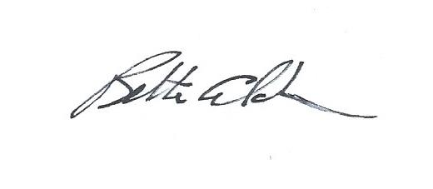
Bette Schans
Director of Assessment of Student Learning

Group Assignments for Essential Learning

Written Communication
Katie Dreiling
Alison Harris
Jason Reddoch
Judy Williams

Oral Communication
Ann Gilles
Jeanine Howe
Suzanne Lay
Tim Pinnow

Critical Thinking
Laureen Cantwell
Carmine Grieco
Kurt Haas
Gary Looft

Quantitative Literacy
Laureen Cantwell
Kelly Jean Craig
Kelly O’Connell
Shawn Robinson
Jun Watabe
David Weinberg

